TABLE OF CONTENTS

S.NO. CONTENT PAGE NO
0.ACKNOWLEDGEMENT 1
1.INTRODUCTION 2
2.OBJECTIVES 3
3.PROJECT CATEGORY 5
4.PROJET SCOPE 7
5.TOOLS/ENVIRONMENT USED 9
- Requirement Specification
- Software System Attributes
- Other Requirement
- ANALYSIS AND DESIGN REPORT
- Design Issue of the Project
6.DATA FLOW DIAGRAM 51
7.ER DIAGRAM 62
8.DATA DICTIONARY 65
9.OUTPUT SCREENS 67
10.CODING 73
11.TESTING 87
12.BIBLIOGRAPHY 90

Acknowledgement

I would like to express my profound gratitude to Dr Monika Varshney (Assistant Professor), HOD of Department of Computer Applications for their contributors to the completion of my project titled “Good Food Restaurant Website”.

I would like to express my special thanks to our mentor Mrs. Usha Gandhar Rathi (Assistant Professor, Department of Computer Applications) for her time and efforts she provided throughout the semester. Her useful advice and suggestions were really helpful to me during the project completion. In this aspect, I am eternally grateful to her.

I would like to acknowledge that this project was completed entirely by me and not by someone else.

Virendra Mathur (2000085011141)
Siddhant Upadhyay (2000085011124)
Tushar Mishra (2000085011135)

1

Chapter 1- Introduction

Introduction
Overview of the project is described in this introduction. In the next sub -section, the motivation is outlined.
1.1-Overview

Good Food Restaurant website is a website which is made by us. In this website, the online food ordering process and daily routine of their restaurant is included. Customers can order food online through this website. In case of take away food or dining there, customer have to visit or call and order. The project is based on automating the above mentioned processes.

The problem that many business face today is to make sure that they attract new customers and also they keep their existing customers.

1.2-Motivation for the Project
The motivation of this project comes with observing their difficulties in busy situation while I was there as I usually visit the place to order food. Personally I don’t have much time to wait in long queues. Some restaurants is very crowded during lunch and dinner time. So, by this restaurant website I easily order food online without any tiredness. Other than that, I value learning web designing and development because it will helpful in future for my carrier.

2

Chapter 2- Objective

Objectives of the Project

The main objective of the Project on Online Food Ordering System is to manage
the details of Food Item, Category, Customer, Order, Confirm Order. It manages all the
information about Food Item, Payment, Confirm Order, Food Item. The project is totally
built at administrative end and thus only the administrator is guaranteed the access. The
purpose of the project is to build an application program to reduce the manual work for
managing the Food Item, Category, Payment, Customer. It tracks all the details about
the Customer, Order, Confirm Order
The main objective of the Project on Online Food Ordering System is to manage
the details of Food Item, Category, Customer, Order, Confirm Order. It manages all the
information about Food Item, Payment, Confirm Order, Food Item. The project is totally
built at administrative end and thus only the administrator is guaranteed the access. The
purpose of the project is to build an application program to reduce the manual work for
managing the Food Item, Category, Payment, Customer. It tracks all the details about
the Customer, Order, Confirm Order
The main objective of the Project on Online Food Ordering System is to manage
the details of Food Item, Category, Customer, Order, Confirm Order. It manages all the
information about Food Item, Payment, Confirm Order, Food Item. The project is totally
built at administrative end and thus only the administrator is guaranteed the access. The
purpose of the project is to build an application program to reduce the manual work for
managing the Food Item, Category, Payment, Customer. It tracks all the details about
the Customer, Order, Confirm Order
The main objective of the Project on Online Food Ordering System is to manage
the details of Food Item, Category, Customer, Order, Confirm Order. It manages all the
information about Food Item, Payment, Confirm Order, Food Item. The project is totally
built at administrative end and thus only the administrator is guaranteed the access. The
purpose of the project is to build an application program to reduce the manual work for
managing the Food Item, Category, Payment, Customer. It tracks all the details about
the Customer, Order, Confirm Order
The main objective of the Project on Online Food Ordering System is to manage
the details of Food Item, Category, Customer, Order, Confirm Order. It manages all the
information about Food Item, Payment, Confirm Order, Food Item. The project is totally
built at administrative end and thus only the administrator is guaranteed the access. The
purpose of the project is to build an application program to reduce the manual work for
managing the Food Item, Category, Payment, Customer. It tracks all the details about
the Customer, Order, Confirm Order
The main objective of the Project on Online Food Ordering System is to manage
the details of Food Item, Category, Customer, Order, Confirm Order. It manages all the
information about Food Item, Payment, Confirm Order, Food Item. The project is totally
built at administrative end and thus only the administrator is guaranteed the access. The
purpose of the project is to build an application program to reduce the manual work for
managing the Food Item, Category, Payment, Customer. It tracks all the details about
the Customer, Order, Confirm Order
The main objective of the Project on Online Food Ordering System is to manage
the details of Food Item, Category, Customer, Order, Confirm Order. It manages all the
information about Food Item, Payment, Confirm Order, Food Item. The project is totally
built at administrative end and thus only the administrator is guaranteed the access. The
purpose of the project is to build an application program to reduce the manual work for
managing the Food Item, Category, Payment, Customer. It tracks all the details about
the Customer, Order, Confirm Order
The main objective of the Project on Online Food Ordering System is to manage
the details of Food Item, Category, Customer, Order, Confirm Order. It manages all the
information about Food Item, Payment, Confirm Order, Food Item. The project is totally
built at administrative end and thus only the administrator is guaranteed the access. The
purpose of the project is to build an application program to reduce the manual work for
managing the Food Item, Category, Payment, Customer. It tracks all the details about
the Customer, Order, Confirm Order
The main objective of the Project on Online Food Ordering System is to manage
the details of Food Item, Category, Customer, Order, Confirm Order. It manages all the
information about Food Item, Payment, Confirm Order, Food Item. The project is totally
built at administrative end and thus only the administrator is guaranteed the access. The
purpose of the project is to build an application program to reduce the manual work for
managing the Food Item, Category, Payment, Customer. It tracks all the details about
the Customer, Order, Confirm Order
The main objective of the Project on Online Food Ordering System is to manage
the details of Food Item, Category, Customer, Order, Confirm Order. It manages all the
information about Food Item, Payment, Confirm Order, Food Item. The project is totally
built at administrative end and thus only the administrator is guaranteed the access. The
purpose of the project is to build an application program to reduce the manual work for
managing the Food Item, Category, Payment, Customer. It tracks all the details about
the Customer, Order, Confirm Order
The main objective of the Project on Online Food Ordering System is to manage
the details of Food Item, Category, Customer, Order, Confirm Order. It manages all the
information about Food Item, Payment, Confirm Order, Food Item. The project is totally
built at administrative end and thus only the administrator is guaranteed the access. The
purpose of the project is to build an application program to reduce the manual work for
managing the Food Item, Category, Payment, Customer. It tracks all the details about
the Customer, Order, Confirm Order
The main objective of the Project on Online Food Ordering System is to manage
the details of Food Item, Category, Customer, Order, Confirm Order. It manages all the
information about Food Item, Payment, Confirm Order, Food Item. The project is totally
built at administrative end and thus only the administrator is guaranteed the access. The
purpose of the project is to build an application program to reduce the manual work for
managing the Food Item, Category, Payment, Customer. It tracks all the details about
the Customer, Order, Confirm Order
The main objective of the Project on Online Food Ordering System is to manage
the details of Food Item, Category, Customer, Order, Confirm Order. It manages all the
information about Food Item, Payment, Confirm Order, Food Item. The project is totally
built at administrative end and thus only the administrator is guaranteed the access. The
purpose of the project is to build an application program to reduce the manual work for
managing the Food Item, Category, Payment, Customer. It tracks all the details about
the Customer, Order, Confirm Order
The main objective of the Project on Online Food Ordering System is to manage
the details of Food Item, Category, Customer, Order, Confirm Order. It manages all the
information about Food Item, Payment, Confirm Order, Food Item. The project is totally
built at administrative end and thus only the administrator is guaranteed the access. The
purpose of the project is to build an application program to reduce the manual work for
managing the Food Item, Category, Payment, Customer. It tracks all the details about
the Customer, Order, Confirm OrderThe main objective of the project on online food ordering system is to manage the Food Item, Category, Customer, Order, Confirm Order. It manages all the information about Food Item, Payment, Confirm Order, Food Item. The project is totally built at administrative end and thus only the administrator guaranteed the access. The purpose of the project is to build an application program to reduce the manual work for managing the Food Item, Category, Payment, Customer. It tracks all the details about the Customer, Order, Confirm Order. For an online food ordering system project, you might consider including objectives such as:
For an online food ordering system project, you might consider including objectives such as:

1-Efficient Order Management: Develop a system that allows users to place orders seamlessly and enables efficient management of orders by the restaurant staff.

2-User-Friendly Interface: Design a user-friendly interface that provides an intuitive and hassle-free experience for customers while navigating the platform.

3-Real-time Updates: Implement real-time order status updates, ensuring customers and restaurant staff are aware of the order progress and estimated delivery times.

4-Menu Display: Create a dynamic menu display that showcases available dishes, their descriptions, prices, and images to help customers make informed choices.

5-Secure Payment System: Integrate a secure payment gateway to facilitate safe and convenient online transactions for users.

6-Customization and Preferences: Allow users to customize their orders by accommodating special instructions, dietary preferences, and portion choices.

7-Feedback and Ratings: Incorporate a feedback and rating system to collect customer opinions and improve the quality of service.

8-Efficient Inventory Management: Develop tools for restaurants to manage their inventory, ensuring accurate availability information for customers.

9-Delivery Tracking: Implement a feature that enables customers to track the delivery process in real-time and receive notifications about the delivery status.
3

10-Promotions and Discounts: Provide a mechanism to offer promotional deals, discounts, and loyalty rewards to attract and retain customers.

11-Mobile Accessibility: Ensure the platform is accessible and functional across various devices, including smartphones and tablets.

12-Scalability: Design the system in a way that allows for easy scalability as the user base and order volume grow over time.

Remember, these objectives should align with the goals of your project and the needs of the users and businesses involved in the online food ordering system.

4
Chapter 3- Project Category

Description: This category encompasses projects related to creating platforms that allow users to order food from various restaurants online. It involves building user-friendly interfaces for customers to browse menus, place orders, make payments, and track deliveries.

Key Features:
Restaurant Listings: Display a list of restaurants with their details.
Menu Browsing: Allow users to browse restaurant menus, view item details, and prices.
Ordering System: Enable users to add items to their cart, adjust quantities, and place orders.
User Authentication: Implement secure login and registration for customers.
Payment Integration: Integrate payment gateways to facilitate secure transactions.
Order Tracking: Provide real-time updates on order status and delivery tracking.
Customer Profiles: Allow users to manage their profiles, addresses, and order history.
Restaurant Management: Provide a platform for restaurant owners to manage their menus, availability, and orders.
Reviews and Ratings: Enable users to leave reviews and rate their dining experiences.
Customer Support: Offer customer support options for inquiries and assistance.

Technologies:

Web Development: HTML, CSS, JavaScript, Bootstrap.
Backend: Server-side scripting languages (e.g., PHP)
Frameworks: Front-end (e.g., React, Angular, Vue.js), Back-end (e.g., Django, Ruby on Rails)
Databases: SQL or NoSQL databases for storing user data, orders, and menus
Payment Gateways: Cash on Delivery (COD).
Security: Encryption, secure authentication, and authorization mechanisms
Ensuring Data Privacy: Safeguarding customer information and payment details.
Real-Time Order Management: Managing orders, stock availability, and delivery logistics.
User Experience: Creating an intuitive and responsive interface for both customers and restaurant owners.
Payment Security: Implementing secure payment gateways to prevent fraud.

5
Scalability: Handling high traffic during peak hours without performance issues.
Delivery Logistics: Integrating with third-party services for efficient order fulfilment.
Remember, your project's scope and specific features may vary based on your goals and requirements. This category provides a broad outline to help you understand the key aspects of an online food ordering website project.

6
Chapter 4- Project Scope

Proposed system is valuable for both customer and the restaurant because it is simplifying the order processing process.
Customers have to create an account with valid phone number or email and can log-in to the system. The web page has up-to-date and interactive menu with all the available food items. When customer made a selection, items added to their order. Customer can review order at any time and change the selection before the payment. Online payment and cash on the collecting counter is possible. Confirmation is prompt to the customer. If it is required, customers can check the table availability and make a table reservation if necessary. Proposed system is not handling delivering food, due to restaurant is not having delivery team.

After a customer placed an order, order details are visible to the kitchen. They can see what the quantity that is required from each item is and they can fulfil multiple orders with same food item in same time. This happens because proposed system can combine orders during allowed time period.

Stock of the ingredients should be always up to date. Otherwise, restaurant cannot fulfil the customer orders properly and may accept orders that cannot be fulfilled due to lack of ingredients. Real-time view of ingredient stock levels is very much important to so much necessary to any restaurant. Then only the meals with enough ingredient stock can be sold. The stock levels will be updated by the kitchen staff at the end of the day through the proposed system.
Restaurant should be able to control the menu items. This ensures that the customers can only order available food items. Only authorized employee can handle the menu. They can create and remove food categories, food items. When creating these categories and food items, employee can add photos and description also. Adding new food items also possible. Remove food items and change visibility of food items. Create and remove options of food items. They can edit und update prices of the food items. They can select “Food Item of the day” and allocate special discount to them.
Giving reasonable discounts to the customers, can keep customers without moving out from the restaurants customer base. First restaurant must identify if the customer is new customer or regular customer. Giving proper discounts to regular customers will increase their satisfaction and they will not move to another restaurant.

7
Restaurant can keep track of all the orders, retrieve and display order information. This information invisible to the kitchen for the order processing. These order details can be useful to report generation.

Customers can give general feedback and suggestions about the restaurant and meals. Those are only visible to the management of the restaurant. Also, customers can give star rating to each and every meal. Other customer can view those when they are selecting their meals. Order logging and report generation are also implemented in proposed system.

8

Chapter 5- Tools/Environment Used

In the development of the Online Food Ordering Website, a combination of tools and environments were employed to ensure seamless execution and efficient collaboration:

Front-end Development: HTML, CSS, JavaScript, Bootstrap
Back-end Development: Node.js (Express framework), PHP
Database: My SQL
Version Control: Git, GitHub
IDE: Visual Studio Code
Project Management: Trello and Slack

5.1- Requirement Specification:
This section lays out the specific requirements that shaped the development of the Online Food Ordering Website. It encompasses both functional and non-functional aspects to ensure comprehensive understanding.

5.1.1-Functional Requirements:
User Registration and Authentication
- Users can create accounts using their email or social media profiles.
- Users must be able to log in securely using email and password.

Restaurant Listing and Menu Browsing
- Users can view a list of restaurants available for ordering.
- Each restaurant will have a menu with items, descriptions, and prices.

Order Placement
- Users can add items to their cart from multiple restaurants.
- Users can customize their orders (e.g., selecting toppings, specifying quantity).
- Users can review their cart before confirming the order.

9
Payment Processing
- Users can choose from various payment methods (card, Cash on delivery, etc.).
- Payment processing must be secure and comply with industry standards.

Order Tracking and Notifications
- Users can track the status of their orders in real-time.
- Users receive notifications (email or SMS) for order confirmation, preparation, and delivery.

User Reviews and Ratings
- Users can rate and provide feedback on restaurants and food items.
- Ratings and reviews are displayed to help other users make informed choices.

5.1.2- Non-Functional Requirements:
Performance
- The system should handle a large number of simultaneous users without significant slowdowns.
- Page load times should be within acceptable limits.
Security
- User data must be securely stored and encrypted.
- Payment information should be handled with utmost security, adhering to industry standards.

Usability and User Experience
- The user interface should be intuitive and responsive across different devices.
- Clear and user-friendly error messages should be provided.

Scalability
- The system architecture should support easy scalability to accommodate increasing user demand.

Compliance
- The system should adhere to relevant data protection regulations (e.g., GDPR).
- Accessibility guidelines should be followed to ensure inclusivity.

10
5.1.3- Technical Requirements:
Programming Languages and Frameworks
- Front-end: React.js
- Back-end: Node.js (Express.js)

Database
- Relational Database Management System: MySQL.

Hosting and Deployment
- Amazon Web Services (AWS)
- Continuous Integration and Continuous Deployment (CI/CD) pipeline

Payment Integration
- Stripe API for payment processing

Real-time Updates
- WebSocket technology with Socket.io for real-time order updates

Security Measures
- HTTPS for secure communication
- JWT for user authentication

5.1.4- User Interface Design:
- The user interface should be clean, visually appealing, and responsive.
- Use colour schemes and typography that align with the brand identity.

5.1.5-Project Management and Communication:
- Jira for task tracking and project management.
- Slack for team communication.

5.1.6- Documentation:
- Comprehensive documentation for APIs, codebase, and system architecture.

11
5.1.7- Third-Party Integration:
- Google Maps API for location services.
- SendGrid API for email notifications.
This sample requirement specification provides a structured outline of what should be covered in your document. You can customize it further based on your project’s specific needs and the preferences of your team and stakeholders.

5.2- Software System Attribute:
Certainly, here are some software system attributes that are important for an online food ordering system:

5.2.1-Reliability:
- The system should be available and functional at all times to ensure customers can place orders without disruptions.
- Implement mechanisms to handle errors gracefully and recover from failures without data loss.

5.2.2-Scalability:
- The system should be designed to handle increased user traffic during peak hours or special events.
- Scalability can be achieved through load balancing, caching, and utilizing cloud infrastructure.

5.2.3-Performance:
- The system should respond quickly to user actions, ensuring minimal loading times for pages and menu items.
- Optimize database queries and use appropriate caching strategies to improve performance.

5.2.4-Security:
- Implement strong authentication and authorization mechanisms to protect user accounts and data.
- Ensure that payment information and personal details are encrypted during transmission and storage.

12
5.2.5-Usability and User Experience (UX):
- The user interface should be intuitive and easy to navigate.
- Ensure a consistent and user-friendly design across different devices (desktop, tablet, mobile).
5.2.6-Maintainability:
- Write clean, well-documented code that is easy to understand and modify.
- Use modular design and adhere to coding standards to facilitate future updates and enhancements.

5.2.7-Compatibility:
- Ensure that the application works correctly on various web browsers and devices.
- Consider responsiveness and cross-browser compatibility during development.

5.2.8-Interoperability:
- Design the system to interact with external services, such as payment gateways and location APIs.
- Use standardized data formats (e.g., JSON, XML) for communication.

5.2.9-Data Integrity:
- Implement data validation to ensure that only accurate and valid data is processed.
- Use proper database constraints and data validation rules to maintain data integrity.

5.2.10-Data Privacy and Compliance:
- Ensure that the system complies with data protection regulations like GDPR.
- Allow users to control their data and provide clear privacy policies.

5.2.11-Error Handling and Logging:
- Implement comprehensive error handling to provide users with meaningful error messages.
- Maintain detailed logs to track system behaviour, troubleshoot issues, and improve performance.
5.2.12-Testing and Quality Assurance:
- Conduct thorough testing, including unit tests, integration tests, and user acceptance tests.
- Use testing frameworks to automate and streamline the testing process.

13
5.2.13-Real-time Updates:
- Implement real-time notifications and updates for order status changes and important events.

5.2.14-Accessibility:
- Ensure that the application is accessible to users with disabilities by adhering to accessibility standards (e.g., WCAG).

5.2.15-Backup and Recovery:
- Regularly backup the system's data and ensure a reliable recovery mechanism in case of data loss or system failure.

5.2.16-Documentation:
- Maintain comprehensive documentation for the system's architecture, APIs, endpoints, and deployment processes.
These attributes collectively contribute to the success of an online food ordering system by providing a reliable, secure, and user-friendly experience for both customers and restaurant owners.

5.3- Other Requirements:
Certainly, in addition to the software attributes, an online food ordering system may have various other requirements to meet the needs of users, restaurants, and the overall business. Here are some additional requirements to consider:

5.3.1-Search and Filtering:
- Implement search functionality for users to find restaurants and dishes quickly.
- Allow users to filter results based on cuisine type, price range, ratings, etc.

5.3.2-Guest Checkout:
- Provide an option for users to place orders without creating an account.
- Allow them to enter essential information for delivery and payment.

5.3.3-Order History and Tracking:
- Users should be able to view their order history and track the status of current orders.
- Display estimated delivery times and updates on the preparation and delivery process.
14
5.3.4-Location-Based Services:
- Integrate with location services or allow users to manually enter their delivery address.
- Calculate accurate delivery fees based on distance.

5.3.5-Restaurant Dashboard:
- Provide a dashboard for restaurant owners to manage their menus, view orders, and update availability.
- Allow restaurants to set operating hours and manage their online presence.

5.3.6-Inventory Management:
- Ensure that restaurants can manage their inventory in real-time to avoid accepting orders for unavailable items.

5.3.7-Promotions and Discounts:
- Implement a system for applying promotional codes and discounts during order checkout.
- Allow restaurants to offer special deals and promotions.

5.3.8-Feedback and Ratings Management:
- Provide a way for restaurant owners to respond to customer reviews and ratings.
- Enable restaurants to view and analyse feedback for improvement.

5.3.9-Multi-Language Support:
- Offer the application in multiple languages to cater to a diverse user base.

5.3.10-Multi-Currency Support:
- If applicable, support different currencies for payments and pricing.

5.3.11-Social Media Integration:
- Allow users to share their orders and reviews on social media platforms.
- Enable quick registration and login through social media accounts.
5.3.12-Push Notifications:
- Implement push notifications to keep users informed about order updates, promotions, and new restaurants.
15

5.3.13-Customer Support Integration:
- Provide a support system for users to contact customer service in case of issues or inquiries.

5.3.14-Advanced Search and Recommendations (Optional):
- Offer personalized recommendations based on users' past orders and preferences.
- Implement an advanced search feature that considers user behaviour and trends.

5.3.15-In-App Chat or Support Bot (Optional):
- Provide a chatbot or in-app messaging system to assist users with common queries and issues.
5.3.16-Offline Mode (Optional):
- Allow users to browse menus and place orders even when temporarily offline, with data synchronization once connectivity is restored.

5.3.17-Integration with Delivery Partners (Optional):
- If collaborating with delivery services, integrate with their APIs for smooth order handover and delivery tracking.

5.3.18-Customer Loyalty Programs (Optional):
- Allow users to earn points or rewards for frequent orders, encouraging customer retention.
Remember that these requirements might vary based on your specific business model, target audience, and technological capabilities. Customizing the system to fulfil these needs will enhance user satisfaction and the overall success of the online food ordering platform.

5.4- Analysis And Design Report:
5.4.1- Executive Summary:
An online food ordering system is a digital platform that allows customers to browse menus, place orders, and make payments for food items from a variety of restaurants and eateries. This system offers a convenient and user-friendly way for users to explore different cuisines, select dishes, customize orders, and have meals delivered to their doorstep or prepared for pickup.
Key Features:
1-User Registration and Authentication: Customers can create accounts or log in using their credentials. This allows for personalized experiences, order history tracking, and loyalty programs.

16
2-Restaurant Listings: The system provides a comprehensive list of partnered restaurants with their menus, prices, and special offers. Users can filter and search for restaurants based on their preferences.
3-Menu Browsing: Users can browse menus with detailed item descriptions, images, and prices. They can also view special dietary information and available customization options.
4-Order Placement: Customers can add desired items to their cart, specify quantities, make special requests, and customize orders based on their preferences.
5-Cart Management: The system allows users to review their selected items, make modifications, and proceed to checkout.
6-Payment Integration: Secure payment gateways enable users to make payments online using various methods such as credit/debit cards, digital wallets, or other electronic payment options.
7-Real-time Tracking: Some systems offer order tracking features that allow users to monitor the status of their orders, from preparation to delivery.
8-Notifications: Users receive confirmation emails or in-app notifications regarding order placement, payment confirmation, and delivery status updates.
9-User Reviews and Ratings: Customers can provide feedback and ratings for the food and service they receive, helping other users make informed decisions.
10-Admin Dashboard: Restaurant owners and administrators have access to a dashboard where they can manage menus, update prices, view orders, and track business performance.
11-Delivery and Pickup Options: Users can choose between delivery and pickup options based on their convenience.
12-Customer Support: The system may offer customer support through chatbots, FAQs, or direct contact with customer service representatives.
In summary, an online food ordering system simplifies the process of discovering, ordering, and receiving food from a variety of restaurants, offering convenience and flexibility to both customers and restaurant owners.
Purpose:
The purpose of the Online Food Ordering System Analysis and Design Report is to provide a comprehensive and structured overview of the entire process involved in developing an online platform for food ordering. This report serves as a detailed documentation of the analysis and design phases of the project, aiming to communicate the project's goals, strategies, decisions, and outcomes to various stakeholders, including project managers, developers, designers, testers, investors, and clients.
The report serves several key purposes:
1-Documentation: The report documents the entire process of analysing and designing the online food ordering system, capturing the decisions made, methodologies followed, and technologies utilized. This documentation is crucial for future reference, troubleshooting, and updates.
2-Communication: The report serves as a communication tool that conveys the project's scope, objectives, design considerations, and implementation details to all stakeholders involved. It ensures a clear understanding of the project's architecture and design choices.
17
3-Decision-Making: The report provides an in-depth rationale for the design decisions taken, such as the system architecture, database structure, security measures, and user interface design. This information helps stakeholders understand the reasoning behind each choice.
4-Guidance: For developers and designers, the report serves as a guide during the implementation phase. It outlines the system's components, interactions, and workflows, aiding in consistent and accurate development.
5-Quality Assurance: The report helps ensure the quality and integrity of the project by detailing the testing strategy, test cases, and performance considerations. This information guides the testing team in validating the system's functionality.
6-Transparency: Clients and investors can use the report to gain transparency into the project's progress and the strategies employed. It demonstrates that the project is being developed in a structured and planned manner.

7-Training and Onboarding: For future maintainers and administrators of the system, the report provides a resource for understanding the system's architecture, components, and how different pieces interact. It can aid in training and onboarding new team members.
8-Reference for Future Updates: As the system evolves and requires updates, the report serves as a reference point for understanding the existing design. This is particularly useful when deciding how to integrate new features or modify existing ones.
9-Evaluation: The report can be used for project evaluation and assessment. It allows stakeholders to compare the project's outcomes with its initial objectives and evaluate the effectiveness of the design and implementation strategies.
In essence, the Online Food Ordering System Analysis and Design Report is a critical document that captures the essence of the project's design, methodologies, and considerations. It serves as a bridge between the conceptualization phase and the actual implementation, ensuring that the final system aligns with the project's goals and requirements.

Key Findings and Recommendations:

Key Findings:
1-User Experience (UX) Optimization: The user interface of the online food ordering system is user-friendly and intuitive, facilitating easy navigation and order placement. Users appreciate the clear menu presentation and customization options.
2-Mobile Responsiveness: The system's mobile responsiveness is commendable, enabling users to access and use the platform seamlessly on various devices. This is crucial as a significant portion of users access the system via mobile phones.
3-Secure Payment Processing: The integration of secure payment gateways has resulted in smooth and secure online transactions. Users trust the payment process, which is essential for maintaining user satisfaction.

18
4-Order Tracking: The implementation of real-time order tracking has significantly improved the user experience. Users appreciate being able to track the progress of their orders from preparation to delivery.
5-Restaurant Collaboration: The platform's ability to collaborate with a diverse range of restaurants has expanded the variety of cuisines available to users. This variety has contributed to attracting a broader customer base.
Recommendations:
1-Enhanced Personalization: Implement a recommendation engine that suggests food items based on user preferences and past orders. This can enhance user engagement and drive upselling.
2-Multi-Language Support: Introduce multi-language support to cater to a more diverse user base. This feature can significantly improve the accessibility and usability of the platform.
3-Review and Rating Moderation: Implement a robust system for monitoring and moderating user reviews and ratings. This will help maintain the credibility of the reviews and ensure that they provide accurate insights to other users.
4-Improved Customer Support: Enhance the customer support options by introducing a chatbot for addressing common queries and issues. Additionally, offer a clear escalation process for more complex problems.
5-Integration with Loyalty Programs: Collaborate with restaurants to integrate their loyalty programs into the platform. This can encourage repeat orders and customer loyalty.
6-Continuous Performance Optimization: Regularly monitor and optimize the system's performance to ensure fast loading times and a smooth user experience during peak hours.
7-Sustainability Initiatives: Collaborate with restaurants to promote sustainable practices, such as eco-friendly packaging and sourcing local ingredients. Highlighting these initiatives can resonate well with environmentally conscious users.
8-Data Analytics for Insights: Implement robust data analytics tools to gather insights into user behaviour, order trends, and popular items. This data can guide marketing strategies and menu planning.
9-Expand Marketing Efforts: Increase marketing efforts to attract new users and promote special deals or limited-time offers. Utilize social media and targeted advertising to reach a wider audience.
10-Regular Software Updates: Maintain a schedule for software updates and bug fixes to ensure that the system remains secure, reliable, and up to date with the latest technologies.
11-Collaboration with Delivery Services: Explore partnerships with reliable third-party delivery services to ensure prompt and reliable order deliveries, especially during peak hours.
12-User Onboarding and Tutorials: Develop user onboarding tutorials or guides for first-time users to help them understand how to use the platform effectively.
These recommendations are based on the identified strengths and opportunities for improvement within the current online food ordering system. Implementing these suggestions can further enhance the user experience, increase customer satisfaction, and contribute to the platform's continued growth and success.
19
5.4.2- Introduction:

Background:
The background of an online food ordering system lies in the evolution of technology and the changing consumer behaviour towards dining and food consumption. This digital solution has transformed the way people order, receive, and enjoy their meals, offering convenience and a plethora of options. Here's a brief overview of the background of online food ordering systems:
Pre-Digital Era: Before the advent of online platforms, ordering food typically involved phone calls to restaurants or visiting eateries in person. This process was time-consuming, often leading to miscommunications and delays. As technology advanced, businesses saw the potential to streamline this process and enhance the customer experience.
Emergence of Online Platforms: The late 1990s and early 2000s saw the emergence of the first online food ordering platforms. These platforms allowed customers to view menus, place orders, and make payments through websites. This marked the initial steps towards digitalizing the food ordering process.
Mobile Revolution: The introduction and widespread adoption of smartphones further revolutionized the food ordering landscape. Mobile apps provided a more convenient way for users to browse menus, customize orders, and track deliveries. This era witnessed the rise of dedicated food delivery apps, which rapidly gained popularity among busy urban populations.
Diverse Cuisine Options: Online food ordering systems not only allowed users to order from local restaurants but also introduced them to a wide range of international cuisines. This variety led to increased experimentation and exploration of different foods, beyond what was traditionally available.
Integration of Third-Party Services: As these platforms gained traction, they began integrating with third-party services, such as GPS navigation and online payment gateways. These integrations streamlined the entire process, from order placement to delivery tracking and payment.
Market Competition and Consolidation: The growing demand for online food ordering led to increased competition among platforms. This competition prompted businesses to improve user experiences, offer promotions, and expand their restaurant partnerships. Over time, some platforms merged or acquired others, leading to consolidation within the industry.
Advanced Features and Personalization: Modern online food ordering systems have evolved to offer advanced features, such as real-time order tracking, customer reviews and ratings, loyalty programs, and personalized recommendations based on user preferences.
Pandemic Impact: The COVID-19 pandemic further accelerated the adoption of online food ordering systems. Lockdowns and restrictions pushed restaurants to rely more heavily on delivery and takeout services, and consumers became more accustomed to ordering food online due to safety concerns.
Sustainability and Social Responsibility: In recent years, there has been an increased emphasis on sustainability and social responsibility within the food industry. Some online food ordering platforms have started collaborating with restaurants that prioritize eco-friendly packaging and sustainable sourcing practices.
20
Future Innovations: The online food ordering industry continues to evolve with the integration of AI-driven chatbots for customer support, voice-activated ordering, virtual kitchens, and even experiments with drone and robot deliveries.
In summary, the background of online food ordering systems is characterized by a gradual shift from traditional ordering methods to digital platforms, driven by technological advancements, changing consumer behaviours, and the need for greater convenience. This transformation has reshaped the restaurant industry and how people experience and enjoy their meals.

Objectives of the Project:

For an online food ordering system project, you might consider including objectives such as:
1-Efficient Order Management: Develop a system that allows users to place orders seamlessly and enables efficient management of orders by the restaurant staff.

2-User-Friendly Interface: Design a user-friendly interface that provides an intuitive and hassle-free experience for customers while navigating the platform.

3-Real-time Updates: Implement real-time order status updates, ensuring customers and restaurant staff are aware of the order progress and estimated delivery times.

4-Menu Display: Create a dynamic menu display that showcases available dishes, their descriptions, prices, and images to help customers make informed choices.

5-Secure Payment System: Integrate a secure payment gateway to facilitate safe and convenient online transactions for users.

6-Customization and Preferences: Allow users to customize their orders by accommodating special instructions, dietary preferences, and portion choices.

7-Feedback and Ratings: Incorporate a feedback and rating system to collect customer opinions and improve the quality of service.

8-Efficient Inventory Management: Develop tools for restaurants to manage their inventory, ensuring accurate availability information for customers.

9-Delivery Tracking: Implement a feature that enables customers to track the delivery process in real-time and receive notifications about the delivery status.
21
10-Promotions and Discounts: Provide a mechanism to offer promotional deals, discounts, and loyalty rewards to attract and retain customers.

11-Mobile Accessibility: Ensure the platform is accessible and functional across various devices, including smartphones and tablets.

12-Scalability: Design the system in a way that allows for easy scalability as the user base and order volume grow over time.
Remember, these objectives should align with the goals of your project and the needs of the users and businesses involved in the online food ordering system.

Scope and Limitations:

Scope of the Project:
The scope of an online food ordering system encompasses the functionalities and features that the system provides to its users and stakeholders. It defines what the system will deliver and what it won't. The scope of an online food ordering system typically includes:
1-User Registration and Authentication: Users can create accounts, log in, and manage their profiles.
2-Restaurant Listings: Display a comprehensive list of partnered restaurants with their menus, prices, and special offers.
3-Menu Browsing: Allow users to browse restaurant menus, view item details, and images.
4-Order Placement: Enable users to add items to the cart, customize orders, and place orders.
5-Cart Management: Provide the ability to view, modify, and finalize the order before checkout.
6-Payment Integration: Integrate secure payment gateways for online transactions.
7-Order Tracking: Offer real-time order tracking from preparation to delivery.
8-Notifications: Send order confirmation and delivery status updates to users.
9-User Reviews and Ratings: Allow users to rate and review restaurants and dishes.
10-Admin Dashboard: Provide restaurant owners/admins a dashboard to manage menus, orders, and business insights.
11-Customer Support: Offer customer support channels for addressing queries and issues.
12-Mobile App Support: Develop mobile applications for iOS and Android platforms.
13-Integration with Third-Party Services: Collaborate with third-party services for maps, payment gateways, and delivery logistics.
14-Data Analytics: Collect and analyse data to understand user preferences and trends.
22
Limitations of Online Food Ordering System:
1-Technical Limitations: System glitches, server downtime, or slow loading times can affect user experience.
2-Delivery Coverage: The system's delivery coverage may be limited to specific areas, excluding some users.
3-Accuracy of Information: Incorrect menu items, prices, or availability can lead to customer dissatisfaction.
4-Availability of Restaurants: Not all restaurants may be available on the platform due to partnerships or technical limitations.
5-Language and Accessibility: The system might lack support for certain languages or accessibility features, excluding some users.
6-Dependency on Third Parties: Reliance on third-party services like payment gateways or delivery partners can lead to issues beyond the system's control.
7-Security Concerns: The system must handle sensitive user data and financial information securely.
8-Cuisine Variety: The variety of cuisines and dishes might not be exhaustive, limiting user options.
9-Quality Control: Ensuring consistent food quality during delivery can be challenging.
10-User Engagement: Maintaining user engagement beyond just ordering (loyalty programs, engagement features) can be a challenge.
11-Privacy Concerns: Users might be concerned about their personal data privacy.
12-Operational Hours: Restaurants might have specific operational hours that affect order availability.
13-Payment Failures: Payment transactions might fail, leading to user frustration.
It's important to address these limitations during the system's design and development to provide the best possible user experience and mitigate potential issues.

5.4.3- System Requirements:
Functional Requirements:
User Registration and Authentication
- Users can create accounts using their email or social media profiles.
- Users must be able to log in securely using email and password.

Restaurant Listing and Menu Browsing
- Users can view a list of restaurants available for ordering.
- Each restaurant will have a menu with items, descriptions, and prices.
23
Order Placement
- Users can add items to their cart from multiple restaurants.
- Users can customize their orders (e.g., selecting toppings, specifying quantity).
- Users can review their cart before confirming the order.

Payment Processing
- Users can choose from various payment methods (credit card, PayPal, etc.).
- Payment processing must be secure and comply with industry standards.

Order Tracking and Notifications
- Users can track the status of their orders in real-time.
- Users receive notifications (email or SMS) for order confirmation, preparation, and delivery.

User Reviews and Ratings
- Users can rate and provide feedback on restaurants and food items.
- Ratings and reviews are displayed to help other users make informed choices.

Non-Functional Requirements:
Performance
- The system should handle a large number of simultaneous users without significant slowdowns.
- Page load times should be within acceptable limits.
Security
- User data must be securely stored and encrypted.
- Payment information should be handled with utmost security, adhering to industry standards.
Usability and User Experience
- The user interface should be intuitive and responsive across different devices.
- Clear and user-friendly error messages should be provided.
Stakeholders Identification:
Stakeholders in an online food ordering system are individuals, groups, or entities that have a vested interest in the system's development, operation, or outcomes. Identifying these stakeholders is crucial for understanding their needs, requirements, and expectations. Here are some key stakeholders in an online food ordering system:

24
1-Users/Clients: The primary stakeholders are the users who use the platform to order food. This includes individuals, families, office workers, and students who rely on the system for their meal requirements.
2-Restaurants and Eateries: The restaurants partnering with the platform are essential stakeholders. They depend on the system to increase their customer reach and streamline their order management processes.
3-Delivery Personnel: If the system involves delivery services, delivery personnel are stakeholders. They rely on the platform for order assignments, navigation, and efficient deliveries.
4-Administrators: Admins manage the platform, oversee restaurant partnerships, monitor orders, and handle technical issues. They ensure the smooth operation of the system.
5-Developers and IT Team: The development team is responsible for creating, maintaining, and updating the platform. They are stakeholders in ensuring the system's functionality and security.
6-Designers: UI/UX designers contribute to the user interface and experience, making them stakeholders in the design and usability of the platform.
7-Marketing Team: The marketing team promotes the platform, attracts users, and collaborates with restaurants. They are stakeholders in the platform's success and growth.
8-Customer Support: Customer support personnel handle user inquiries, complaints, and technical issues, making them integral stakeholders for user satisfaction.
9-Management and Owners: The company's management and owners have a vested interest in the platform's profitability, growth, and strategic direction.
10-Investors and Shareholders: Investors and shareholders who have financially invested in the platform are stakeholders interested in its financial performance and returns.
11-Regulatory Authorities: Depending on the region, health and safety authorities might be stakeholders, ensuring that food safety regulations are followed.
12-Payment Gateway Providers: Companies providing payment gateway services are stakeholders as their services are essential for the platform's operation.
13-Local Communities: The platform can impact local communities, especially if it promotes local restaurants or contributes to job creation.
14-Privacy and Security Auditors: If the system deals with user data, privacy and security auditors ensure compliance with regulations, making them stakeholders in data protection.
15-Competitors: While not direct stakeholders, competitors in the same industry can influence the platform's strategies and innovations.
Understanding the perspectives and needs of these stakeholders is crucial for creating a successful online food ordering system that meets the requirements of all involved parties

25
5.4.4- System Architecture:

High-Level Architecture Diagram:
A high-level architecture diagram for an online food ordering system typically consists of several key components that work together to provide a seamless user experience. Here's a simplified high-level architecture diagram:
+-------------------+
| User Interface | +-------------------+
| (Web/Mobile App)|<------------>| Application |
+-------------------+ | Logic & |
| Business Rules |
+-------------------+
|
+--------------------------|--------------------------+
| | |
+-------------------+ +-------------------+ +-------------------+
| Authentication | | Order | | Payment |
| & Authorization | | Management | | Processing |
+-------------------+ +-------------------+ +-------------------+
| | |
+--------------------------|--------------------------+
|
+-------------------+
| Database |
| Management |
+-------------------+
Explanation of Components:
1-User Interface (Web/Mobile App): This is the front-end of the system where users interact with the platform. It includes features like browsing menus, placing orders, customizing items, and tracking orders.
2-Authentication & Authorization: This component handles user authentication (login, registration) and ensures that authorized users have access to the system's features.
3-Application Logic & Business Rules: This component manages the core functionality of the system. It handles user requests, processes orders, calculates prices, and applies business rules (discounts, promotions).
26
4-Order Management: This component manages the entire lifecycle of an order. It includes functions like order creation, modification, and cancellation. It also interfaces with the delivery component.
5-Payment Processing: This component interfaces with payment gateways to securely process user payments. It ensures that transactions are smooth and secure.
6-Database Management: The database component stores and manages data related to users, restaurants, menus, orders, and more. It provides a structured way to store and retrieve information.
These components work together to provide a seamless user experience. For example, a user logs in through the authentication component, interacts with the user interface to browse menus and place an order, and then the application logic processes the order, interacts with the database to store relevant data, and possibly connects with external services for payment processing and delivery management.
Keep in mind that the architecture can be more complex based on additional features like real-time order tracking, loyalty programs, and third-party integrations. The diagram provided here offers a simplified overview.

System Components (front-end, back-end, database):
An online food ordering system consists of three main system components: the front-end, the back-end, and the databases. These components work together to provide a seamless and functional user experience. Here's an overview of each component:

Front-end:
The front-end is the user-facing part of the system, where users interact with the platform. It includes the user interface and presentation layer, allowing users to view menus, place orders, and manage their profiles. The front-end is responsible for delivering a visually appealing and user-friendly experience.
Key Responsibilities:
- Displaying restaurant menus, images, and item details.
- Allowing users to customize orders and select preferences.
- Managing user authentication and registration.
- Providing real-time order tracking and notifications.
- Ensuring responsive design for various devices (desktop, tablet, mobile).
Technologies: HTML, CSS, JavaScript, Bootstrap etc).

27
Back-end:
The back-end is the server-side component that handles the core logic of the application. It processes user requests, communicates with databases, performs business logic, and manages security and authentication. The back-end serves as the brain of the system, processing user inputs and generating appropriate responses.
Key Responsibilities:
- Managing user sessions and authentication.
- Handling order processing and management.
- Communicating with external services (payment gateways, delivery services).
- Implementing business rules, discounts, and promotions.
- Validating user inputs and ensuring data integrity.
- Managing APIs for communication between front-end and back-end.
Technologies: Node.js, (Express Framework), PHP etc).

Databases:
Databases store and manage the structured data required for the application's operation. They store user profiles, restaurant details, menus, orders, and more. Efficient and secure database management is crucial to ensuring data accuracy and quick retrieval.
Key Responsibilities:
- Storing user data (profiles, order history).
- Maintaining restaurant and menu information.
- Managing order records and statuses.
- Priding data for reporting and analytics.
- Ensuring data security and access control.
Technologies: Relational Databases (MySQL), Database Management Systems.
It's important to note that these components need to work together seamlessly to provide a cohesive user experience. Communication between the front-end and back-end occurs through APIs, allowing data to flow between the user interface and the application logic. The back-end interacts with the databases to retrieve and store information, ensuring that user actions and data are properly managed.

Technologies and Tools Used:
The choice of technologies and tools for an online food ordering system can depend on factors such as the development team's expertise, project requirements, scalability needs, and security considerations. Here are some common technologies and tools used in building such systems:

28

Front-End Technologies:
- HTML, CSS, JavaScript, Bootstrap: The fundamental web technologies for creating the user interface.

Back-End Technologies:
- Node.js, PHP: A versatile runtime for building scalable and efficient server-side applications.
Databases:
- Relational Databases: MySQL Server are commonly used for structured data storage.

API Development:
- RESTful APIs: Used for communication between the front-end and back-end components.
- GraphQL: Provides more flexibility in data retrieval and offers efficient queries.

Authentication and Security:
- JWT (JSON Web Tokens): For secure user authentication and authorization.
- OAuth: Used to authenticate users through third-party services like Google or Facebook.
- Encryption Libraries: Libraries like bcrypt for securing sensitive data like passwords.

Payment Integration:
- Stripe, PayPal, Braintree: Payment gateways to handle online transactions.

Mapping and Location Services:
- Google Maps API, Manbox: For integrating map and location features.

Version Control and Deployment:
- Git: Version control system for tracking code changes.
- CI/CD Tools: Jenkins, Travis CI, GitLab CI for automating build and deployment processes.
Containerization and Orchestration:
- Docker: For creating containers to package and distribute applications.
- Kubernetes: Orchestration tool for automating deployment, scaling, and management of containerized applications.

29
Cloud Services:
- AWS, Azure, Google Cloud: Cloud platforms for hosting and scaling applications.

Monitoring and Analytics:
- New Relic, Google Analytics: Tools for monitoring application performance and user interactions.

Collaboration and Communication:
- Slack, Microsoft Teams: Communication tools for project collaboration and team coordination.

Project Management:
- Jira, Trello, Asana: Tools for tracking tasks, managing sprints, and project planning.

The choice of specific technologies and tools should be based on the project's requirements, the development team's expertise, scalability needs, and the desire to incorporate the latest industry best practices.

5.4.5- Use Case Analysis:

primary actors (users, admins, restaurants):
In an online food ordering system, there are typically three primary actors that interact with the system: users, admins, and restaurants. Each of these actors has distinct roles and responsibilities within the system.
Users:
Users are the customers who use the online food ordering platform to browse menus, place orders, and make payments. They interact with the system primarily through the user interface provided by the platform's website or mobile app. Users have various roles and actions within the system:
- Browsing Menus: Users can search for restaurants, view menus, and explore different food options.
- Placing Orders: Users can add items to their cart, customize orders, and finalize their orders for checkout.
- Payment: Users provide payment information and select payment methods for online transactions.
- Tracking Orders: Users can track the status of their orders, from preparation to delivery, through real-time tracking.
30
- Review and Ratings: After receiving their orders, users can rate and review restaurants and dishes.

Admins:
Admins are responsible for managing and overseeing the operation of the online food ordering platform. They have administrative privileges and access to back-end tools that allow them to control various aspects of the system. Admins' roles include:
- Restaurant Management: Admins can onboard and manage restaurants, including verifying information and menus.
- Menu and Item Management: Admins can manage menus, add or remove items, and update prices.
- Order Management: Admins can view and manage orders, track delivery status, and handle any issues.
- User Support: Admins assist users with inquiries, troubleshoot problems, and provide customer support.
- Reports and Analytics: Admins access data and generate reports on order trends, user behaviour, and business performance.

Restaurants:
Restaurants are partners in the online food ordering system. They collaborate with the platform to showcase their menus and receive orders for delivery or pickup. Restaurants have specific responsibilities within the system:
- Menu Setup: Restaurants provide detailed menus, item descriptions, images, and prices for the platform.
- Order Fulfilment: Once orders are received, restaurants prepare and package the food for delivery or pickup.
- Order Updates: Restaurants update order statuses (accepted, prepared, dispatched) to keep users informed.
- Communication: Restaurants may communicate with users or the platform for any order-related queries.
These primary actors work collaboratively to create a seamless experience for users seeking to order food from restaurants through the online platform. The interactions among users, admins, and restaurants drive the platform's functionality and success.

Use Case Diagram:
A use case diagram for an online food ordering system visually represents the interactions between different actors and the system's functionalities. Here's a simplified use case diagram for such a system:

31
+-------------------+
| User |
+-------------------+
| |
+-------|------|-------+
| | | |
+----------------+ +------------------+
| Browse Menus | | Place Order |
+----------------+ +------------------+
| |
+-------|------|-------+
| | | |
+----------------+ +------------------+
| Track Orders | | Rate & Review |
+----------------+ +------------------+

+-------------------+
| Admin |
+-------------------+
|
+-------|------+
| | |
+----------------+ +------------------+
| Manage Restaurants | Manage Orders |
+----------------+ +------------------+

+-------------------+
| Restaurant |
+-------------------+
|
+-------|------+
| | |
32
+----------------+

| Manage Menu |
+----------------+

Explanation of Use Cases:
User:
- Browse Menus: Users can search for restaurants, view menus, and explore different food options.
- Place Order: Users can add items to their cart, customize orders, and finalize orders for checkout.
- Track Orders: Users can track the status of their orders, from preparation to delivery, through real-time tracking.
- Rate & Review: After receiving orders, users can rate and review restaurants and dishes.

Admin:
- Manage Restaurants: Admins can add and manage restaurant partnerships, verify information, and oversee menus.
- Manage Orders: Admins can view and manage orders, track delivery status, and handle order-related issues.

Restaurant:
1-Manage Menu: Restaurants can manage menus, add or remove items, update prices, and keep their offerings up-to-date.
The use case diagram provides a high-level overview of the interactions and functionalities of the various actors within the online food ordering system. It helps visualize how users, admins, and restaurants engage with the system's features. Keep in mind that this is a simplified representation, and the actual use cases may involve more detailed interactions and sub-actions.

Main Use Cases (user registration, menu browsing, order placement, etc.):
Certainly, here are the main use cases for an online food ordering system:

User Registration:
1-Actors: User
1-Description: Users can create new accounts on the platform by providing necessary information such as name, email, and password.

33
2-Flow:
2.1-User provides registration information.
2.2-System validates and saves the user's data.
2.3-User receives a confirmation email or notification.

User Login:
1-Actors: User
1-Description: Registered users can log into their accounts to access personalized features and order history.
2-Flow:
2.1-User provides login credentials.
2.2-System validates credentials and grants access.

Menu Browsing:
1-Actors: User
1-Description: Users can browse restaurant menus to explore available food items and dishes.
2-Flow:
2.1-User selects a restaurant to view its menu.
2.2-System displays the restaurant's menu with categories and items.
2.3-User selects items to view details.

Order Placement:
1-Actors: User, Restaurant
1-Description: Users can select items from the menu, customize orders, and place orders for delivery or pickup.
2-Flow:
2.1-User adds items to the cart.
2.2-User customizes items (e.g., toppings, quantity).
2.3-User reviews the order in the cart.
2.4-User proceeds to checkout and selects delivery or pickup.
2.5-User provides delivery address or pickup details.
2.6-System calculates the total cost.
2.7-User confirms the order and makes a payment.
34
Order Tracking:
1-Actors: User, Restaurant, Delivery
1-Description: Users can track the status of their orders, from preparation to delivery.
2-Flow:
2.1-User selects an ongoing order to track.
2.2-System displays real-time updates on order status.
2.3-User receives notifications for order progress.

Review and Rating:
1-Actors: User, Restaurant
1-Description: Users can provide feedback by rating restaurants and writing reviews.
2-Flow:
2.1-User selects a completed order to review.
2.2-User rates the restaurant and adds a review.
2.3-System records the review and rating.
2.4-Review is displayed on the restaurant's profile.

Admin Management:
1-Actors: Admin
1-Description: Admins can manage restaurants, menus, and orders.
2-Flow:
2.1-Admin adds new restaurants to the platform.
2.2-Admin verifies and approves menus and offerings.
2.3-Admin manages and tracks orders.

Restaurant Menu Management:
1-Actors: Restaurant
1-Description: Restaurants can manage their menus, add or remove items, and update prices.
2-Flow:
2.1-Restaurant logs into their account.
2.2-Restaurant edits menu items, descriptions, and prices.
2.3-System updates the menu with the changes.
35
These are the core use cases of an online food ordering system, capturing the essential functionalities that users, admins, and restaurants interact with during their engagement with the platform.

5.4.6- Data Design:

Entity-Relationship Diagram:
An Entity-Relationship Diagram (ERD) visually represents the relationships between entities (objects or concepts) in a system. Here's a simplified example of an ERD for an online food ordering system:
+-------------------+
| User |
+-------------------+
| User ID (PK) |
| Name |
| Email |
| Phone |
+-------------------+
|
+-------------------+
| Order |
+-------------------+
| Order ID (PK) |
| User ID (FK) |
| Restaurant ID (FK) |
| Order Date |
| Total Amount |
| Status |
+-------------------+
|
+-------------------+
| Restaurant |
+-------------------+
| Restaurant ID (PK) |
36
| Name |
| Address |
| Phone |
+-------------------+
|
+-------------------+
| Menu |
+-------------------+
| Menu ID (PK) |
| Restaurant ID (FK) |
| Item Name |
| Price |
| Category |
+-------------------+
|
+-------------------+
| Order Item |
+-------------------+
| Order Item ID (PK) |
| Order ID (FK) |
| Menu ID (FK) |
| Quantity |
+-------------------+

Explanation of Entities:
User:
- Represents users of the system who place orders.
- Contains attributes like User ID, Name, Email, and Phone.

Order:
- Represents individual orders placed by users.
- Contains attributes like Order ID, User ID (foreign key referring to User), Restaurant ID (foreign key referring to Restaurant), Order Date, Total Amount, and Status.
37
Restaurant:
- Represents the partnering restaurants on the platform.
- Contains attributes like Restaurant ID, Name, Address, and Phone.

Menu:
- Represents the menu items offered by restaurants.
- Contains attributes like Menu ID, Restaurant ID (foreign key referring to Restaurant), Item Name, Price, and Category.

Order Item:
- Represents individual items within an order.
- Contains attributes like Order Item ID, Order ID (foreign key referring to Order), Menu ID (foreign key referring to Menu), and Quantity.
This simplified ERD captures the relationships between users, orders, restaurants, menus, and order items in an online food ordering system. Keep in mind that the actual ERD can be more complex depending on additional features and relationships within the system.

Database tables and relationships
Sure, here's an overview of the database tables and their relationships for an online food ordering system:
User Table:
1-Columns: User ID (Primary Key), Name, Email, Phone, Password (Hashed), Address, Registration Date

Restaurant Table:
1-Columns: Restaurant ID (Primary Key), Name, Address, Phone\

Menu Table:
1-Columns: Menu ID (Primary Key), Restaurant ID (Foreign Key referencing Restaurant), Item Name, Price, Category

Order Table:
1-Columns: Order ID (Primary Key), User ID (Foreign Key referencing User), Restaurant ID (Foreign Key referencing Restaurant), Order Date, Total Amount, Status

38
Order Item Table:
1-Columns: Order Item ID (Primary Key), Order ID (Foreign Key referencing Order), Menu ID (Foreign Key referencing Menu), Quantity

Relationships:
- One User can place Many Orders (One-to-Many between User and Order).
- One Order is associated with One User (Many-to-One between Order and User).
- One Order can contain Many Order Items (One-to-Many between Order and Order Item).
- One Order Item belongs to One Order (Many-to-One between Order Item and Order).
- One Order Item corresponds to One Menu Item (Many-to-One between Order Item and Menu).
- One Menu belongs to One Restaurant (Many-to-One between Menu and Restaurant).
- One Restaurant can have Many Menus (One-to-Many between Restaurant and Menu).
This structure establishes the relationships between the entities in the database, enabling efficient data retrieval and management within the online food ordering system. Keep in mind that this is a simplified representation, and in a real-world scenario, you might need to consider additional tables for features like reviews, ratings, payment information, and more.

Processes and Data Flows:
User Interface:
- Handles user interactions such as placing orders, browsing menus, and tracking orders.
- Receives user inputs and passes them to relevant processes.

Admin Interface:
- Allows admins to manage orders and menus.
- Communicates with the database to retrieve and update data.

Restaurant Interface:
- Enables restaurants to manage their menus.
- Interacts with the database to update menu information.

Place Order:
- Takes user's order details and processes them.
- Communicates with the database to save order information.

39
Manage Orders:
- Handles order management tasks by admins.
- Retrieves order data from the database and updates order status.

Manage Menus:
- Allows restaurants to update their menus.
- Communicates with the database to update menu items.

Database:
- Stores and retrieves data related to users, orders, menus, and more.

These DFDs provide a high-level overview of data flows and processes within the online food ordering system. The actual DFDs could be more detailed, including additional processes, data stores, and interactions.

5.4.7- System Design:

Detailed design of system components:
Sure, let's dive into a more detailed design of the system components for an online food ordering system:

Front-End Component:
1-User Interface Design: Design user interfaces (UI) for various user actions:
1.1-Home page with featured restaurants and search functionality.
1.2-Restaurant pages displaying menus, images, and details.
1.3-Cart and checkout pages for order placement.
1.4-Order tracking page with real-time updates.
1.5-User profile and order history pages.

2-Responsive Design: Ensure the UI is responsive and compatible with different devices and screen sizes.
3-User Authentication and Authorization: Implement user registration, login, and role-based access controls.

40
Back-End Component:
1-API Design and Development: Design RESTful APIs to facilitate communication between the front-end and back-end.
User Management:
- Implement user registration and authentication mechanisms.
- Manage user profiles, including personal information and order history.

Order Management:
- Process order placement, customization, and checkout.
- Calculate total order amounts, taxes, and discounts.
- Handle order status updates (e.g., preparing, dispatched, delivered).

Restaurant Management:
- Allow restaurants to register and manage their profiles.
- Enable restaurant verification and menu submission.

Admin Panel:
- Develop an admin dashboard for order and restaurant management.
- Provide tools for reviewing and managing orders and menus

Menu Management:
- Implement functionality for adding, updating, and deleting menu items.
- Support categorization and customization of items.

Payment Processing:
- Integrate with payment gateways to securely process transactions.
- Handle payment status and confirmations.

Order Tracking:
- Implement real-time order tracking through integration with external services or notifications.
Security Measures:
- Apply security best practices to prevent unauthorized access and data breaches.
- Use encryption for sensitive data (e.g., passwords, payment details).

41
Database Component:
Database Design:
- Design a normalized database schema to store user data, orders, menus, and other relevant information.

User Data:
- Store user profiles, authentication data, and order history.

Order Data:
- Maintain records of orders, including order details, timestamps, and statuses.

Restaurant and Menu Data:
- Store information about registered restaurants and their menus.

Data Relationships:
- Establish appropriate relationships between tables using primary and foreign keys.

Integration and External Services:
Payment Gateways:
- Integrate with payment providers (e.g., Stripe, PayPal) for secure payment processing.

Map Services:
- Integrate map APIs (e.g., Google Maps) for location-based features.

Notification Services:
- Integrate with notification services to provide real-time updates to users.

Deployment and Scaling:
- Choose appropriate cloud platforms (e.g., AWS, Azure) for hosting the application.
- Implement containerization (e.g., Docker) for easy deployment and scaling.
- Utilize load balancing and auto-scaling to handle varying levels of traffic.

42
Remember that these are high-level descriptions, and each component may involve multiple sub-components and detailed implementation strategies. Collaboration among developers, designers, and other team members is crucial to ensure the successful design and development of the online food ordering system.

5.4.8-Security Design:
Authentication and authorization mechanisms:
Authentication and authorization mechanisms are critical components of an online food ordering system to ensure that users have secure access to the platform and that their actions are controlled appropriately. Here's a detailed explanation of these mechanisms:
Authentication:
Authentication is the process of verifying the identity of a user to ensure that they are who they claim to be. In an online food ordering system, authentication is typically required to access user-specific features and to protect user data.
- User Registration:
  - Users create accounts by providing their name, email, password, and other required information.
  - Passwords are securely hashed and stored in the database.
- Login:
  - Users enter their credentials (email and password) to log in.
  - The system verifies the credentials by comparing the provided password's hash with the stored hash.
- Social Login (Optional):
  - Users can log in using their social media accounts (e.g., Google, Facebook) for convenience.
  - OAuth or similar protocols are used for social login.
- Authentication Tokens:
  - Upon successful login, the system generates authentication tokens (e.g., JWTs) and sends them to the client.
  - Tokens are included in subsequent requests to authenticate the user.
- Session Management:
  - Sessions are maintained for user interactions during their visit.
  - Sessions can be stored in server memory or cookies with secure attributes.
Authorization:
Authorization determines what actions authenticated users are allowed to perform within the system. It defines access levels and restrictions based on roles and permissions.
43
- Role-Based Access Control (RBAC):
  - Users are assigned roles (e.g., User, Admin, Restaurant Owner) with associated permissions.
  - Permissions define what actions or resources each role can access.
- Access Control Lists (ACLs):
  - ACLs can be used to specify fine-grained access control for specific resources.
  - For example, restaurants may have control over their own menus but not other restaurants' menus.
- Middleware and Filters:
  - Middleware or filters intercept requests and check the user's role and permissions before allowing access to certain routes or actions.
- Admin Controls:
  - Admins have elevated permissions and can access all parts of the system, typically through a separate admin panel.
- Ownership and Data Isolation:
  - Ensure that users can only access their own data. For example, a user can edit their own profile but not someone else's.

Security Considerations:
- Implement secure password storage by using strong hashing algorithms (e.g., encrypt).
- Use HTTPS to encrypt data in transit.
- Implement account lockout mechanisms to prevent brute-force attacks.
- Set up rate limiting to mitigate password guessing attacks.
- Regularly audit and update permissions and roles to maintain security.
By implementing robust authentication and authorization mechanisms, an online food ordering system can protect user data, prevent unauthorized access, and ensure that users have appropriate levels of access to the system's features.
Data encryption:
Data encryption is crucial in an online food ordering system to protect sensitive information from unauthorized access and breaches. Here are key areas where data encryption should be implemented:
- Password Storage:
  - Store user passwords securely by hashing them with a strong cryptographic hashing algorithm like bcrypt. Do not store plain text passwords.
  - Apply salting to passwords before hashing to add an extra layer of security.

44
- Data in Transit (SSL/TLS):
  - Use HTTPS (HTTP Secure) to encrypt data transmitted between the user's browser and the server. This includes user login credentials, payment details, and any other sensitive information.
  - Implement SSL/TLS certificates to establish a secure connection. Ensure these certificates are up to date and properly configured.
- Data at Rest:
  - Encrypt sensitive data stored in databases, such as user profiles, payment information, and order history.
  - Consider using database encryption features or third-party encryption tools to protect data at rest.
- Authentication Tokens:
  - If your system uses authentication tokens (e.g., JWTs), ensure that they are signed and encrypted to prevent tampering.
  - Employ strong algorithms and keys for token encryption and signing.
- Payment Information:
  - Comply with Payment Card Industry Data Security Standard (PCI DSS) requirements for handling payment information.
  - If you store payment data, encrypt it with strong encryption algorithms and ensure that access is strictly controlled.
- Configuration Files:
  - Encrypt sensitive information in configuration files, such as database connection strings and API keys.
  - Store encryption keys and secrets securely, separate from the codebase.
- Mobile Apps:
  - If your system has a mobile app component, encrypt data stored on the user's device to protect it from unauthorized access or theft.
  - Implement secure storage practices and consider using platform-specific encryption tools.
- Logging and Auditing:
  - Protect log files and audit trails by limiting access and encrypting sensitive log data.
  - Be cautious not to log sensitive user data in plaintext.
- APIs and External Integrations:
  - Ensure that data exchanged with third-party APIs or external systems is transmitted securely using encryption protocols.

45
- Key Management:
  - Implement strong key management practices to protect encryption keys. Store keys in secure vaults or Hardware Security Modules (HSMs).
- Regular Security Audits:
  - Conduct regular security audits and penetration testing to identify vulnerabilities and weaknesses in your encryption practices.
- Compliance:
  - Stay informed about data protection regulations and compliance requirements relevant to your region (e.g., GDPR, HIPAA) and implement encryption measures accordingly.
- Employee Training:
  - Train your development and operations teams on encryption best practices to ensure consistent implementation.
Remember that encryption is just one component of a comprehensive security strategy. It should be combined with other security measures, such as access controls, security patches, and intrusion detection systems, to provide robust protection for your online food ordering system.

Measures against common security threats:
An online food ordering system should be designed with security in mind to protect user data, financial information, and the integrity of the platform. Here are measures against common security threats:
- SQL Injection:
  - Use prepared statements or parameterized queries to prevent SQL injection attacks.
  - Implement input validation and sanitize user inputs to reject malicious SQL code.
- Cross-Site Scripting (XSS):
  - Employ output encoding for user-generated content displayed on web pages.
  - Use Content Security Policy (CSP) headers to mitigate XSS attacks.
- Cross-Site Request Forgery (CSRF):
  - Implement anti-CSRF tokens in forms to verify the authenticity of requests.
  - Ensure state-changing actions (e.g., order placement) are protected against CSRF attacks.
- Authentication Bypass:
  - Implement secure authentication mechanisms, such as password hashing (encrypt).
  - Use multi-factor authentication (MFA) for added security.
46
- Insecure Direct Object References (IDOR):
  - Validate user access to resources and ensure they have proper authorization.
  - Avoid exposing sensitive data in URLs, and use server-side checks to verify user permissions.
- Brute Force and Credential Stuffing Attacks:
  - Implement account lockout mechanisms to prevent brute force attacks.
  - Enforce strong password policies and educate users about password security.
  - Monitor login attempts and implement rate limiting.
- Session Management Issues:
  - Use secure, random session IDs and ensure they are regenerated after login.
  - Implement session timeouts to reduce the risk of session hijacking.
- Security Misconfigurations:
  - Regularly review and update security configurations for web servers, databases, and other components.
  - Disable unnecessary services and features to reduce the attack surface.
- Data Exposure and Leakage:
  - Encrypt sensitive data in transit (SSL/TLS) and at rest (database encryption).
  - Implement proper access controls to restrict access to sensitive information.

- Unvalidated Redirects and Forwards:
  - Avoid allowing user-controlled input to determine redirect URLs.
  - Implement whitelist validation for redirect and forward URLs.
- File Upload Vulnerabilities:
  - Restrict file uploads to specific file types and verify file content.
  - Store uploaded files outside the web root directory to prevent direct execution.
- API Security:
  - Secure APIs with proper authentication (e.g., tokens or API keys) and authorization.
  - Implement rate limiting and request validation to protect against abuse.
- Logging and Monitoring:
  - Implement comprehensive logging of security-related events.
  - Regularly review logs and set up alerts for suspicious activities.

47
- Third-Party Component Security:
  - Keep third-party libraries and dependencies up to date to patch known vulnerabilities.
  - Regularly assess and audit third-party services and APIs for security risks.
- Employee Training:
  - Train your development and operations teams on security best practices and conduct security awareness programs.
- Incident Response Plan:
  - Develop and maintain an incident response plan to address security breaches promptly.
- Compliance with Regulations:
  - Stay informed about relevant data protection regulations (e.g., GDPR, HIPAA) and ensure compliance with their requirements.
Security is an ongoing process, and it's essential to continuously assess and improve security measures to protect your online food ordering system against evolving threats. Regular security audits, penetration testing, and threat modelling can help identify vulnerabilities and weaknesses in your system.

5.5- Design Issued of the Project:
Design issues in an online food ordering system can significantly impact the user experience, system performance, and overall success of the project. Addressing these design issues is essential to ensure a smooth and efficient platform. Here are some common design issues that might arise:
- User Interface (UI) Complexity:
  - Issue: A cluttered or complex user interface can confuse users and make navigation challenging.
  - Solution: Prioritize simplicity and intuitive design. Use clear labels, organize information logically, and employ consistent visual elements.
- Inefficient Navigation:
  - Issue: Poorly organized navigation can make it difficult for users to find menus, items, and essential features.
  - Solution: Implement a clear and hierarchical navigation structure. Use breadcrumbs, categories, and search functionality for ease of use.
- Slow Loading Times:
  - Issue: Slow page loading can frustrate users and lead to high bounce rates.
  - Solution: Optimize images, use content delivery networks (CDNs), and implement caching mechanisms to improve loading speeds.
48
- Incomplete Information:
  - Issue: Incomplete or inaccurate menu information can result in order errors and customer dissatisfaction.
  - Solution: Ensure that restaurants provide comprehensive and up-to-date menu details. Implement validation to prevent incomplete submissions.
- Lack of Mobile Responsiveness:
  - Issue: A non-responsive design can deter mobile users from accessing the platform effectively.
  - Solution: Design a responsive layout that adapts to different screen sizes and devices, ensuring a seamless experience on mobile.

- Complicated Checkout Process:
  - Issue: A convoluted checkout process with numerous steps can lead to cart abandonment.
  - Solution: Streamline the checkout process by reducing the number of steps required. Provide clear progress indicators.

- Ineffective Search Functionality:
  - Issue: Inaccurate search results or a lack of filtering options can hinder users from finding specific dishes.
  - Solution: Implement a robust search feature with relevant filters, such as cuisine type, dietary preferences, and price range.
- Security Vulnerabilities:
  - Issue: Insufficient security measures can expose user data to breaches and unauthorized access.
  - Solution: Implement encryption, secure authentication mechanisms, and follow best practices for securing user information.
- Inconsistent Branding:
  - Issue: Inconsistent branding elements across the platform can undermine the platform's identity.
  - Solution: Maintain consistent colours, fonts, and design elements throughout the platform for a cohesive brand experience.
- Limited Payment Options:
  - Issue: Offering only a few payment options can lead to user frustration and abandoned orders.
  - Solution: Integrate a variety of secure payment gateways to cater to different user preferences.
49
- Unoptimized Images:
  - Issue: Large, unoptimized images can slow down page loading and consume bandwidth.
  - Solution: Optimize images for the web by compressing and resizing them without compromising quality.
- Complex Order Tracking:
  - Issue: Confusing or non-intuitive order tracking can lead to user dissatisfaction.
  - Solution: Provide a simple and clear order tracking interface with real-time updates and status explanations.
Addressing these design issues through careful planning, user-centred design principles, and regular usability testing can significantly enhance the overall quality of the online food ordering system and provide users with a positive experience.
application logic processes the order, interacts with the database to store relevant data, and possibly connects with external services for payment processing and delivery management.
Keep in mind that

50me order tracking, loyalty programs, and
Chapter 6- Data Flow Diagram

6.1- Design Techniques:

To model the system, design techniques are used. Object Oriented design, Rapid application development, prototyping and Modern structured design are examples to design techniques that currently used.

For this development Object oriented design techniques has been used. In this method there are advantages such as, code reusable facility, design benefits and maintainable facilities with Objects and classes.

Unified Modelling Language (UML) plays a significant role in Object Orient designing. UML allows programmers easy understand models of objects so that programmers can easily write software. Some of structural and behavioural UML diagrams use for design proposes systems are mentioned below.

- Use case diagrams – This makes clear what are the capabilities of the system.

- Use case narratives – Make use cases more clear

    - Activity diagrams – shows how activities are coordinated to provide a service which can be at different levels of abstraction.

    - DFD’s – Data flow diagrams representing a flow of data through a process or a system.

    - Data flow Diagrams – shows how the objects interact overtime.

    - Class diagrams – this is the main building block in object oriented modelling [8].

51
6.2- Use case diagrams:

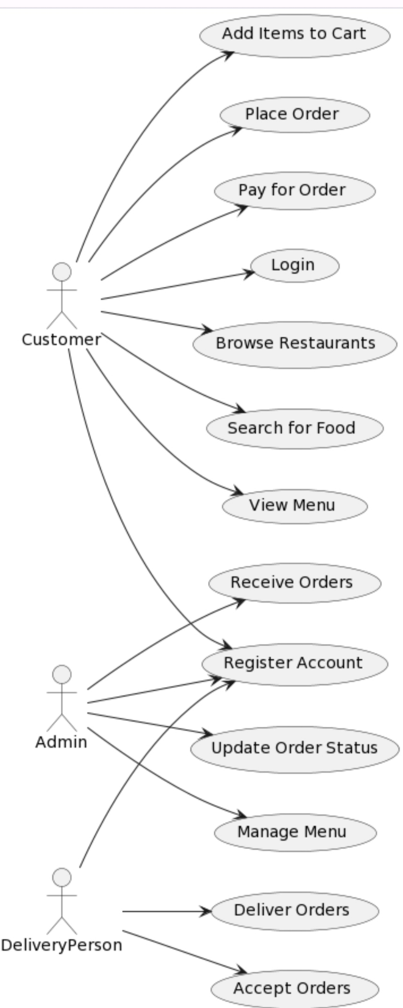

Figure 6.2: Overall High-level Use case for the proposed system.

52
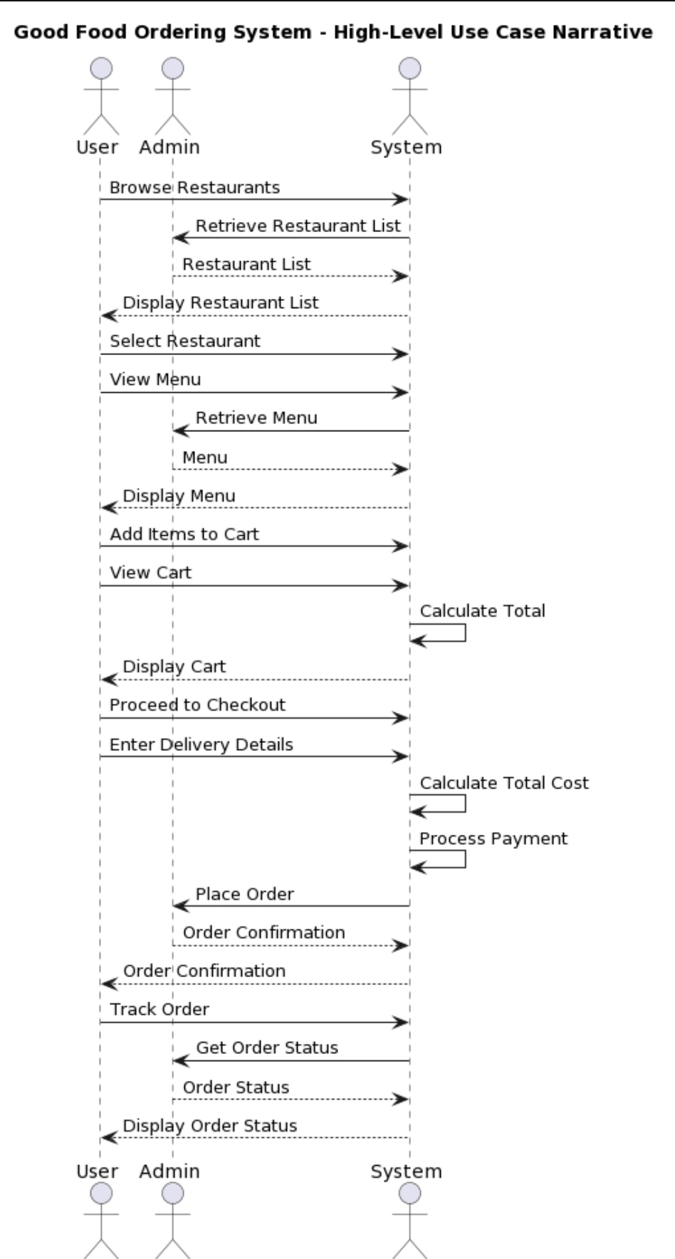

Figure 6.2: use case narrative.

53
6.3- Data base Tables:
A database is a structured collection of data that is organized and stored in a way that allows for efficient retrieval, manipulation, and management. It serves as a central repository for storing various types of information, such as text, numbers, images, and more. Databases are commonly used in various applications, from simple personal record-keeping to complex business systems.

Databases consist of tables, which contain rows and columns. Each row represents a record or data entry, while columns define the different attributes or fields of the data. Databases provide a structured way to store, retrieve, update, and manage data, making them essential for storing and accessing information in a systematic manner.

a table is a fundamental structure used to organize and store data. It consists of rows and columns, forming a grid-like structure. Each row in a table represents a specific record or data entry, while each column represents a different attribute or field of the data.

6.3.1- Admin code table:
These codes are used only for admins.

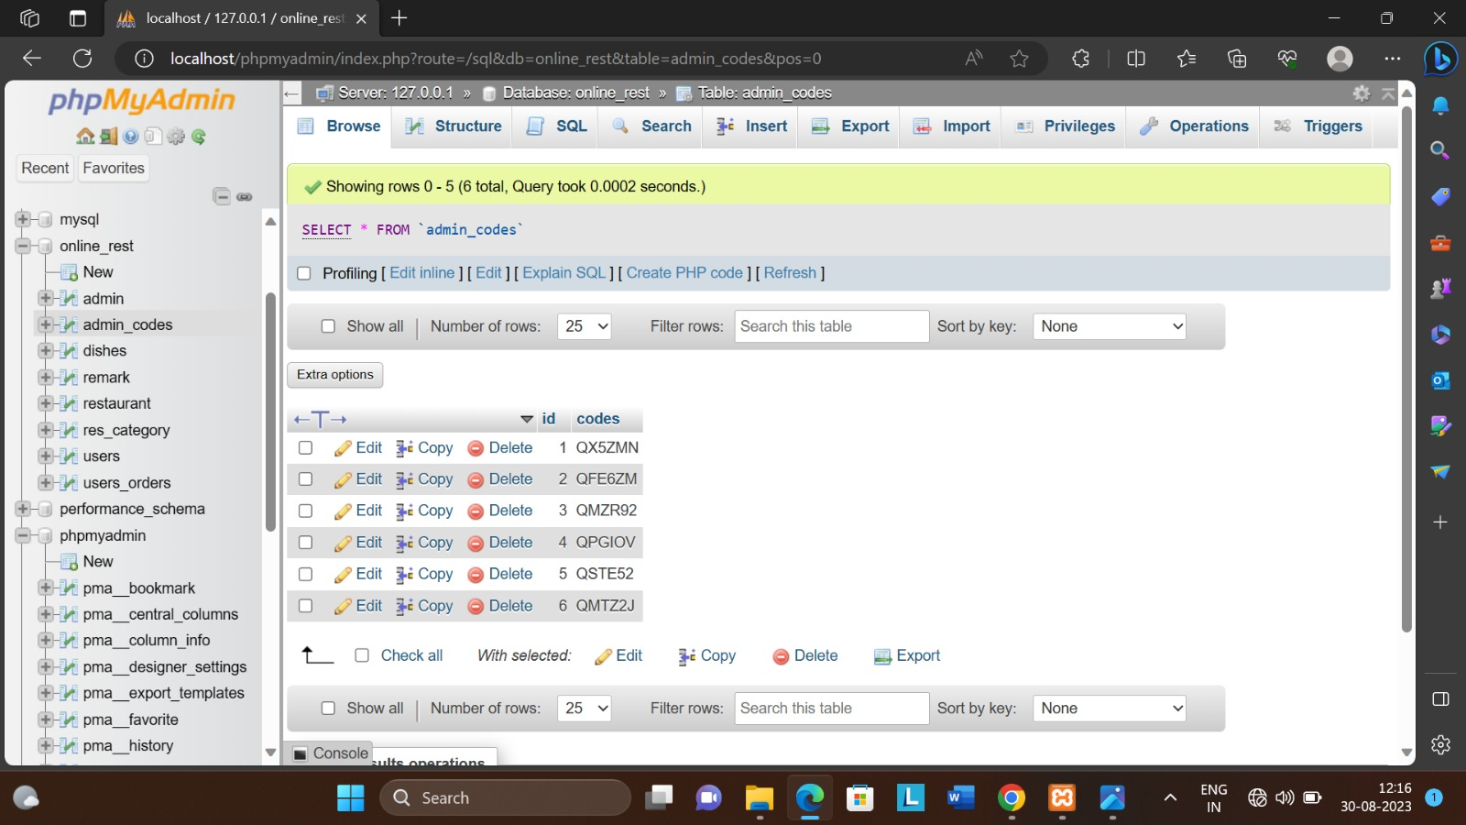

Figure 6.3.1: table of admin codes
54
6.3.2- Restaurants Categories Table:
The user can view the restaurant and admin can change the restaurant name etc.
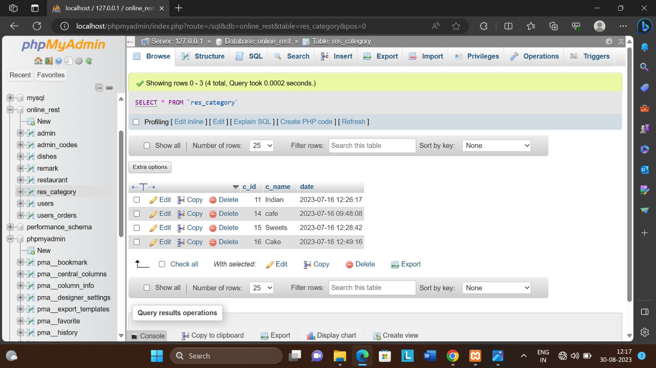

Figure 6.3.2: Table of restaurant categories

6.3.3- Admin table:
The admin table shows the how many admins are there.
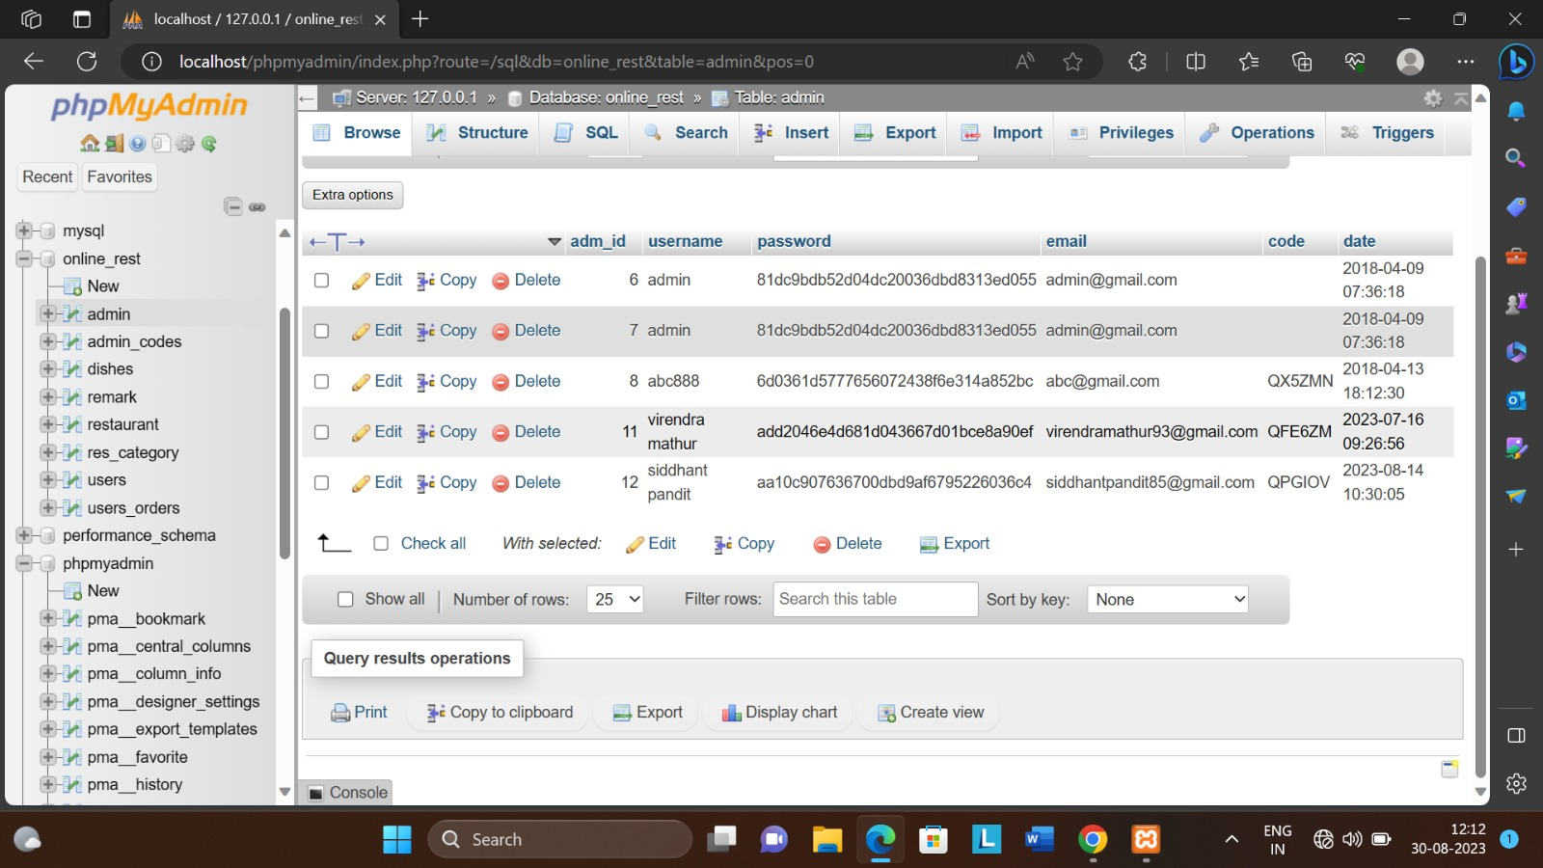

Figure 6.3.3: table of admin
55
6.3.4 Users Orders
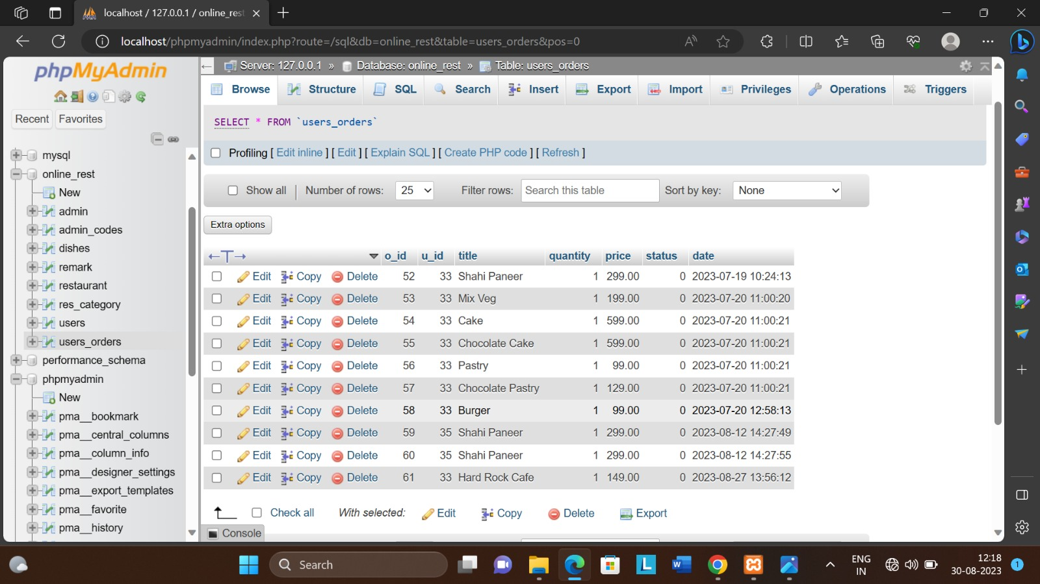
The admin can check the user orders.

Figure 6.3.4: table of users orders.
6.3.5 Restaurant's Table
The admin can add the new restaurant and remove restaurant.
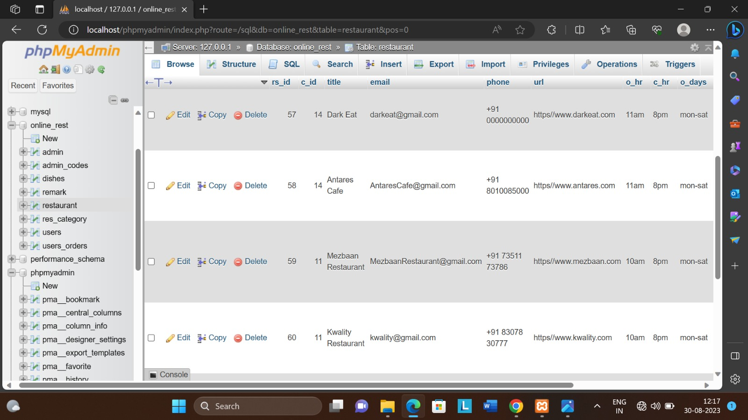

Figure 6.3.5: table of restaurant’s

56
6.3.6 Users Table
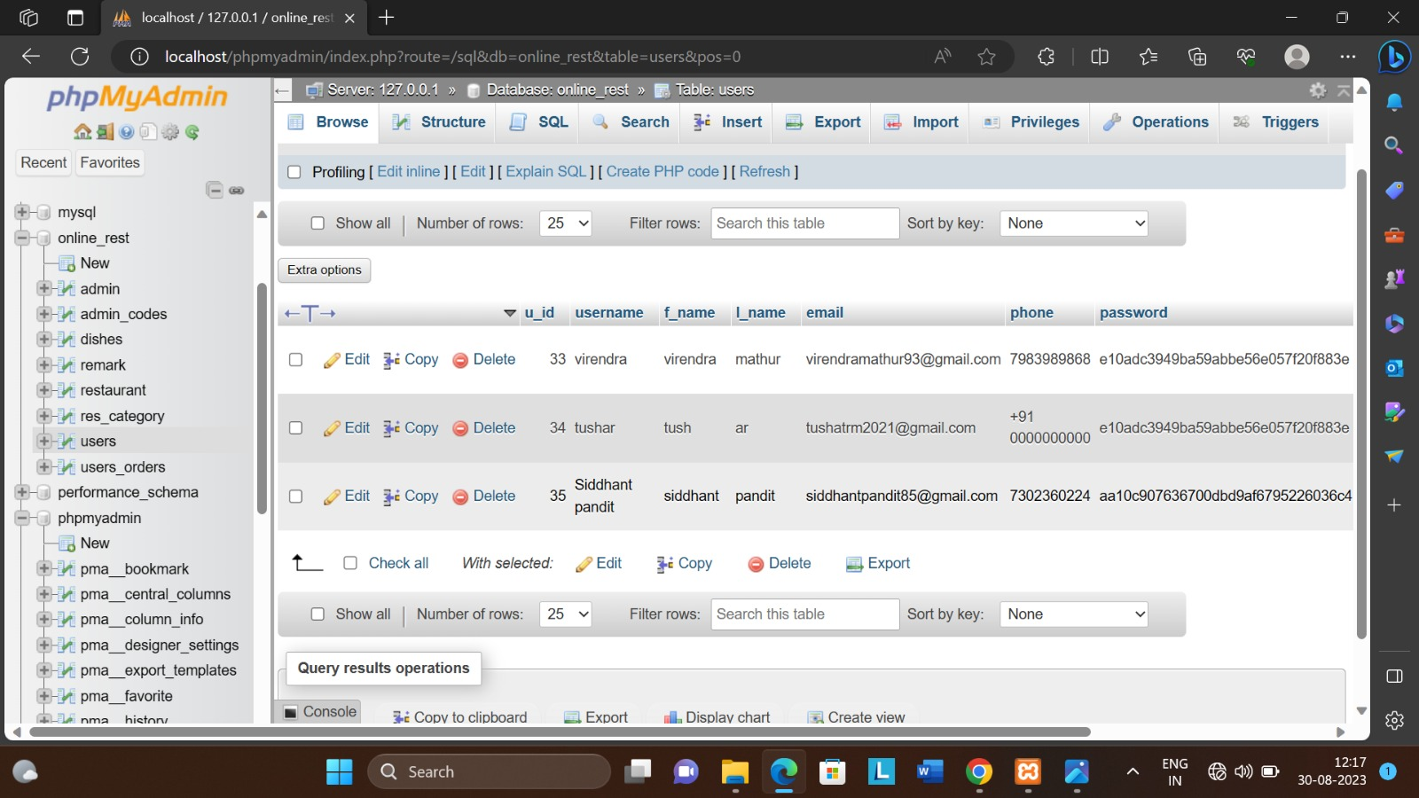
The admin can check the users and users password and add the user & remove the user.

Figure 6.3.6: table of users
6.3.7 Dishes Tables
The dishes table only admin can access that table. Admin can add & remove the dish.

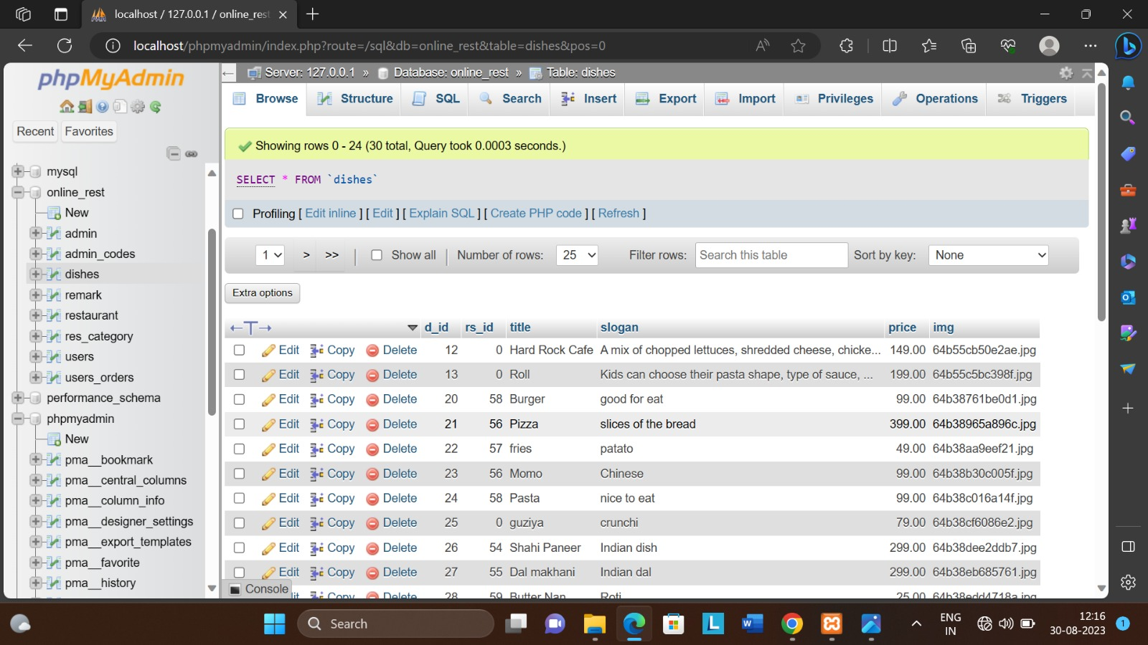
Figure 6.3.7: table of dishes

57
6.4- Activity Diagram:

“Activity diagram is basically a flowchart to represent the flow from one activity to another activity. The activity can be described as an operation of the system.

Activity diagram is suitable for modelling the activity flow of the system. An application can have multiple systems. Activity diagram also captures these systems and describes the flow from one system to another. This specific usage is not available in other diagrams. These systems can be database, external queues, or any other system” [8].

Following figure 3.12 shows activities to order food online.

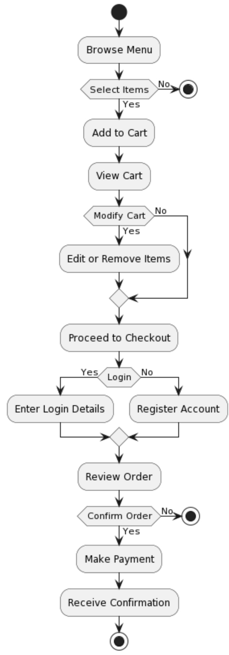

Figure 6.4: user activities

58
6.5- Data Flow Diagram:

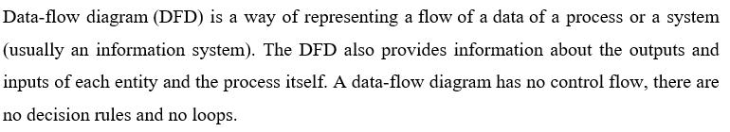

Refer appendix for Level 0, Level 1 and level 2 diagrams.

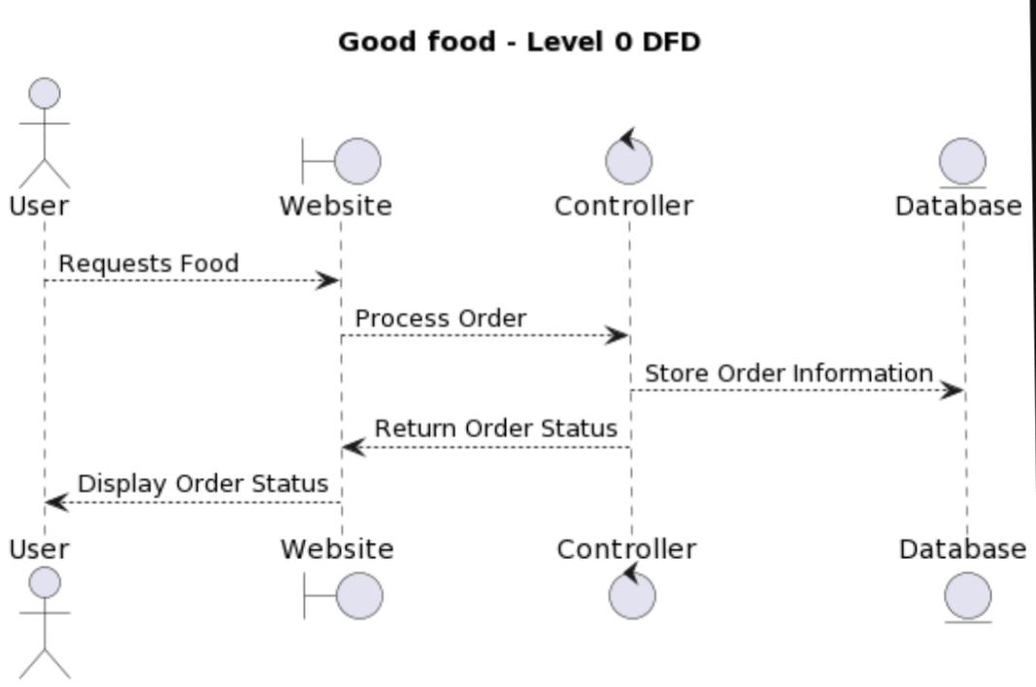
Figure 6.5: Good Food DFD Level 0.

59
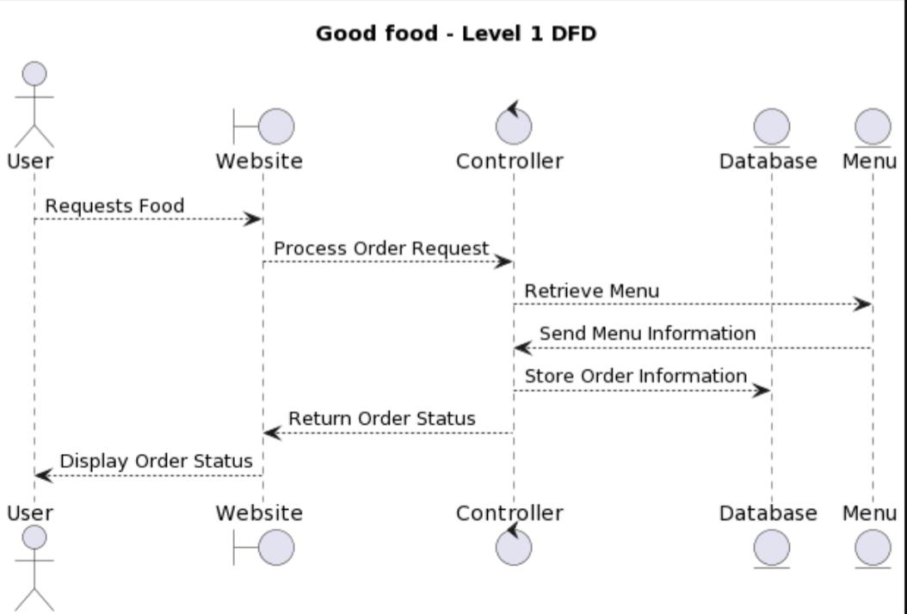

Figure 6.5: good food DFD level 1.
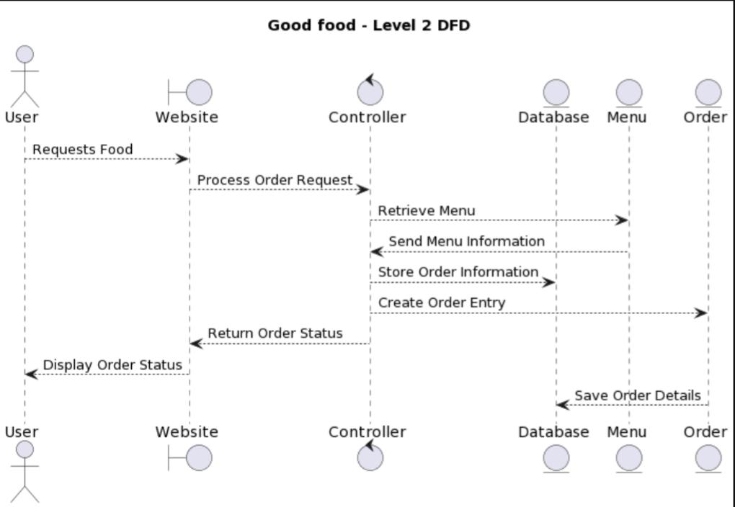
Figure 6.5: good food DFD level 2.
60

6.6- User Interface Design:
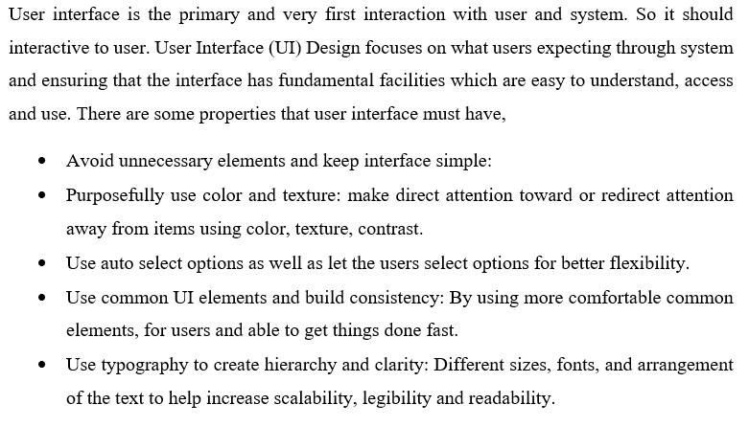
- , log in, and manage their profiles.
- Restaurant Listings: Display a comprehensive list of partnered restaurants with their menus, prices, and special offers.
- Menu Browsing: Allow users to browse restaurant menus, view item details, and images.
- Order Placement: Enable users to add items to the cart, customize orders, and place orders.
- Cart Management: Provide the ability to view, modify, and finalize the order before checkout.
- Payment Integration: Integrate secure payment gateways for online transactions.
- Order Tracking: Offer real-time order tracking from preparation to delivery.
- Notifications: Send order confirmation and delivery status updates to users.
- User Reviews and Ratings: Allow users to rate and review restaurants and dishes.
- Admin Dashboard: Provide restaurant owners/admins a dashboard to manage menus, orders, and business insights.

61

Chapter 7- ER Diagram

7.1- ER diagram:
An Entity-Relationship (ER) diagram is a visual representation used in database design to illustrate the logical structure of a database. It consists of entities (objects or concepts) and their relationships, often depicted using boxes for entities and lines connecting them to represent relationships. ER diagrams help in understanding the data requirements of an application, defining relationships between entities, and creating a blueprint for database creation.
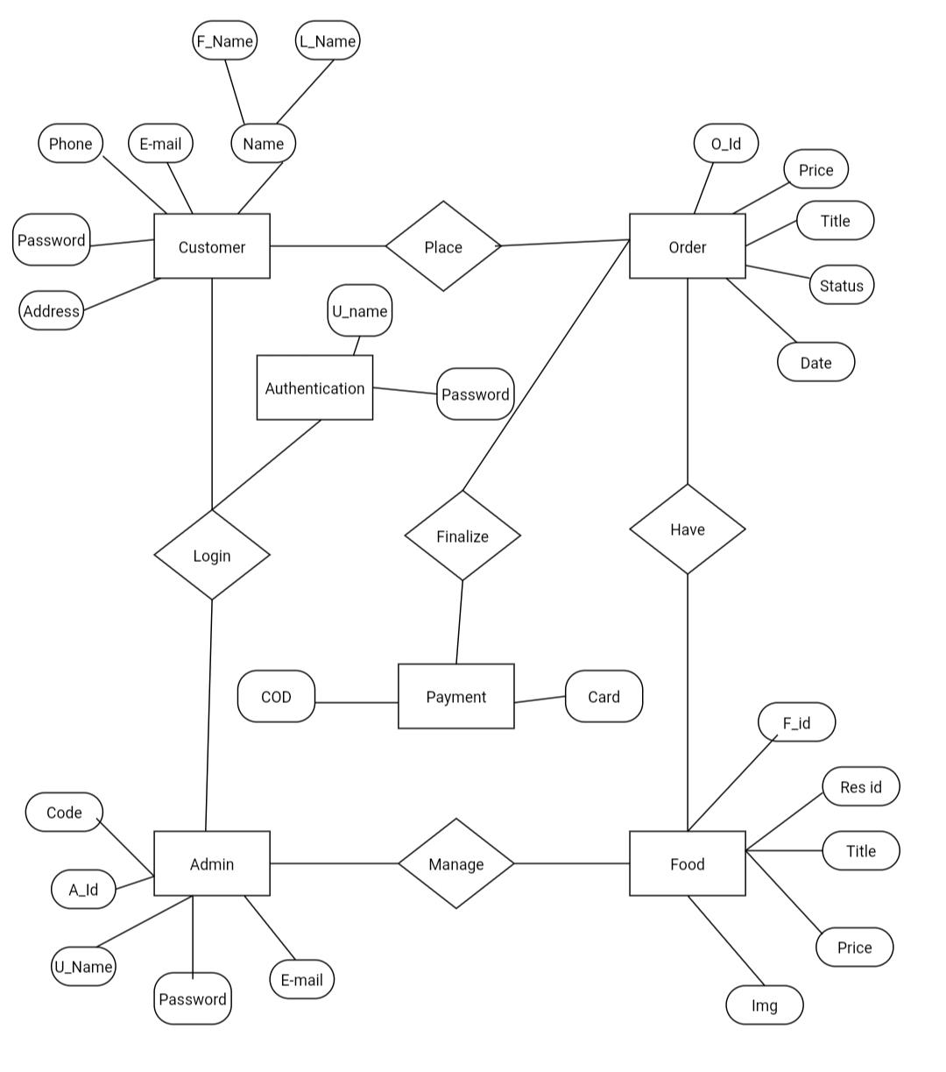
Figure 7.1: good food ordering website ER diagram
62
Customer: customer is an entity. Customer have some attributes name have own two attributes name as F name and L name, customer have E-mail, phone, password, address.
A customer is an individual or entity that purchases goods or services from a business in exchange for payment. Customers are the foundation of any business and play a crucial role in driving revenue and sustaining the organization. Building strong relationships with customers is important for business success, as satisfied customers are more likely to make repeat purchases and recommend the business to others.

Place: place is a relationship between order and customer.
place refers to the website or platform where customers can browse menus, select dishes, and order food from various restaurants for delivery or pickup. It's the virtual space where customers can explore different food options, customize their orders, and complete the transaction. These platforms provide a convenient way for customers to access a wide range of food choices from multiple restaurants all in one place.
Login: login relationship with customer and admin. Customer login our account for ordering food the customer choose favourite restaurant then order your food.
Certainly! A login is a process that allows a user to access a secure system or application by providing valid credentials, such as a username and password. It's a security measure designed to ensure that only authorized individuals can access certain resources or perform specific actions. Once you've entered your credentials, the system verifies them and grants you access if they are correct. If you need help with anything related to logins or security, feel free to ask!
Admin login our account to manage the order and many other management.

Admin: admin have many attributes unique code without unique code admin does not create another account. Admin id is an attribute every admin have own admin id.
Admin is short for "administrator." An administrator is a person or account with elevated privileges and control over a computer system, network, website, application, or organization. Administrators often have the authority to manage settings, permissions, user accounts, and various aspects of the system or organization they oversee. They play a crucial role in maintaining the functionality, security, and organization of digital environments.
Username every admin have own user name without username admin can’t login own account.
Password: A password is a secret combination of characters (such as letters, numbers, and symbols) that is used to authenticate a user’s identity and grant them access to a computer system, online account, or other digital resource. It serves as a security measure to protect personal information and data from unauthorized access. It’s important to choose strong and unique passwords to enhance security.
E-mail: Email, short for "electronic mail," is a method of exchanging digital messages between people using electronic devices such as computers, smartphones, or tablets. These messages can contain text, images, attachments, and other media. Email allows individuals to communicate with one another over the internet, making it a convenient and widely used form of communication for both personal and professional purposes.

63
Food: Food is an entity in every online food ordering website. It have some attributes food id, title, slogan, restaurant id, price, image.
food refers to the various dishes, meals, and culinary offerings that customers can browse, select, and order through the platform. These could include a wide range of options such as appetizers, main courses, desserts, beverages, and more, offered by different restaurants or food establishments. Customers can explore menus, view descriptions and images of the available food items, customize their orders, and then place their selections for delivery or pickup. The online food ordering website acts as a virtual marketplace for these food choices, making it convenient for customers to access a diverse array of dining options from the comfort of their own homes.
Order: the user(customer) use the online food ordering website for ordering the favourite food. Order have many attributes order id, price, title, date, status.
Order refers to a customer’s request to purchase specific food items from a restaurant or eatery listed on the platform. When a customer selects items from the menu, customizes their choices (such as specifying ingredients or portion sizes), and proceeds to complete the transaction, they are placing an order. The order includes details such as the selected dishes, any special instructions, delivery or pickup preferences, and payment information. The online food ordering website then processes the order and facilitates its preparation and delivery by the restaurant or delivery service

7.2- Payment Cash on Delivery:
"Cash on Delivery" (COD) is a payment method often used in e-commerce and online services. With COD, customers can make a purchase online but pay in cash when the product or service is delivered to them in person. This method is particularly popular in regions where online payment systems or credit card usage might not be as widespread or trusted.
In the context of an online food ordering website, offering "Cash on Delivery" as a payment option means that customers can place food orders online and choose
to pay for their orders in cash when the delivery arrives at their doorstep. This can help increase customer convenience and accessibility, especially for those who might not have access to online payment methods.
For businesses implementing this payment method, it's important to have a clear process for confirming orders, ensuring accurate delivery addresses, and coordinating with delivery personnel to collect the payment. It also involves managing the associated logistics and potentially dealing with cases where customers might not have the exact amount of cash on hand.
Keep in mind that while COD provides convenience to customers, it also presents operational challenges, such as managing cash collection, handling returns or cancellations, and ensuring the safety of delivery personnel.

customer OS gateways, and delivery logistics.
- Data Analytics: Collect and
64

64
Chapter 8- Data Dictionary

8.1-Data Dictionary:

Entity: Restaurant
Attributes:
Restaurant ID (Primary Key)
Restaurant Name
Cuisine Type
Location
Contact Information (Phone, Email)
Entity: Menu Item

Attributes:
Item ID (Primary Key)
Item Name
Description
Price
Category
Restaurant ID (Foreign Key referencing Restaurant entity)
Entity: Customer

Attributes:
Customer ID (Primary Key)
First Name
Last Name
Email
Phone Number
Address
Entity: Order

65

Attributes:
Order ID (Primary Key)
Customer ID (Foreign Key referencing Customer entity)
Order Date
Total Amount
Status (Pending, Delivered, etc.)
Entity: Order Item

Attributes:
Order Item ID (Primary Key)
Order ID (Foreign Key referencing Order entity)
Item ID (Foreign Key referencing Menu Item entity)
Quantity
Entity: Payment

Attributes:
Payment ID (Primary Key)
Order ID (Foreign Key referencing Order entity)
Payment Date
Payment Amount
Payment Status
Entity: Delivery

Attributes:
Delivery ID (Primary Key)
Order ID (Foreign Key referencing Order entity)
Delivery Date
Delivery Address
Delivery Status

66
Chapter 9- Output screens

9.1- Admin:
9.1.1- Admin Dashboard:

Controlling the system can be done using this panel. Administrator have privileges to do following functions

1. | Restaurant’s Management | 5. | Purchase Management
2. | Menu Management | 6. | Offers and Discounts
3. | User Management | 7. | Report Generation
4. | Order Management

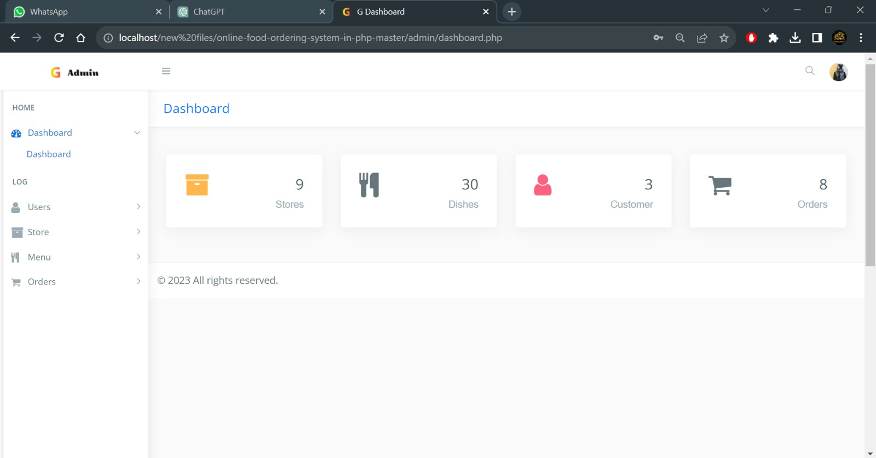

Figure 9.1.1: Admin Dashboard

67
9.1.2- Users:

The admin can check the users and orders of users.
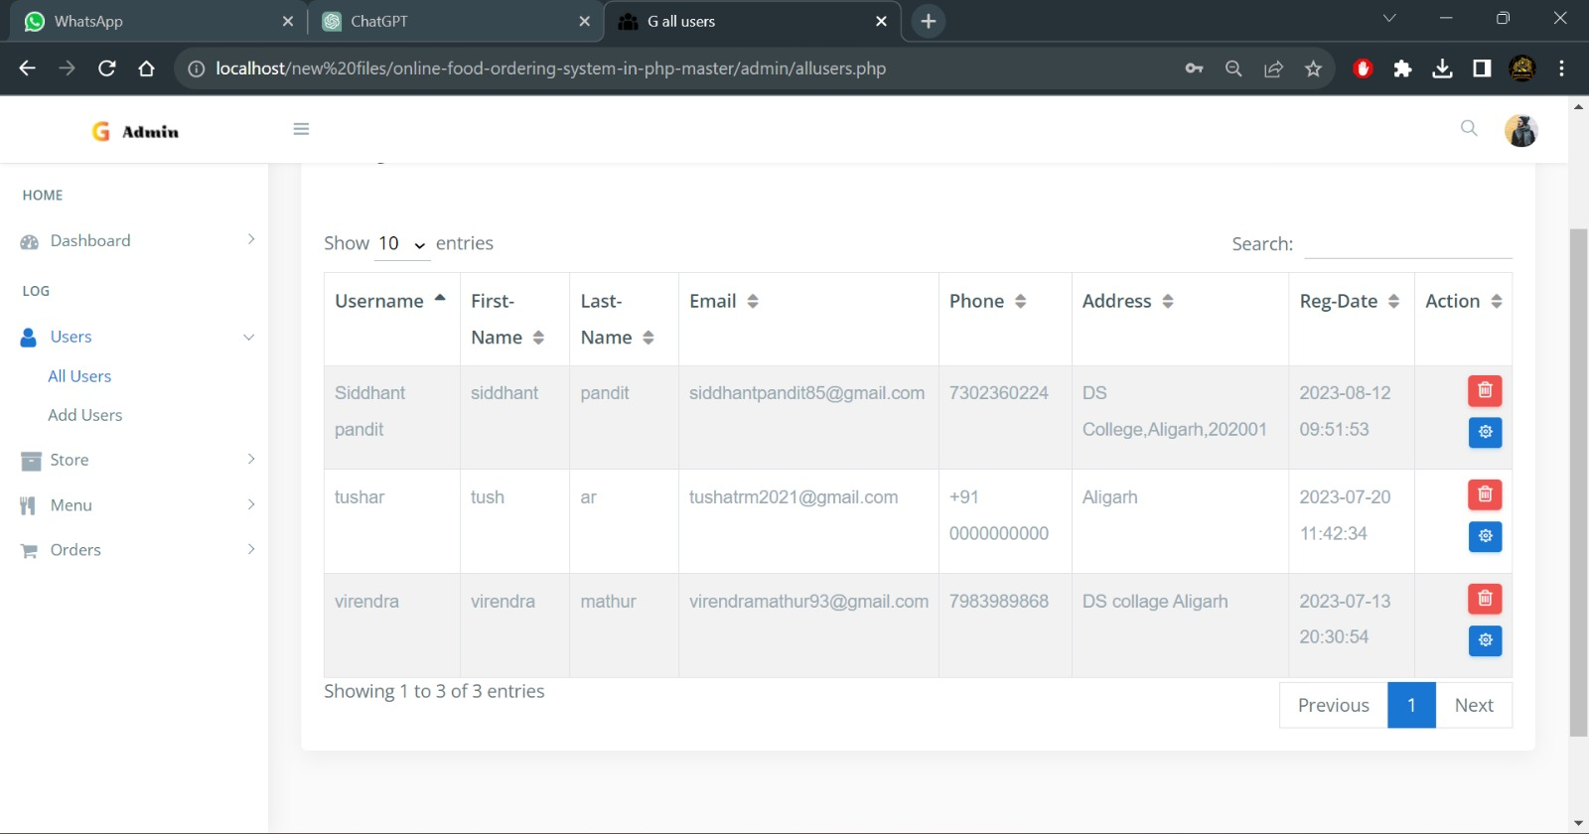

Figure 9.1.2: Users

68
9.1.3- Orders:

The admin can check the customers orders

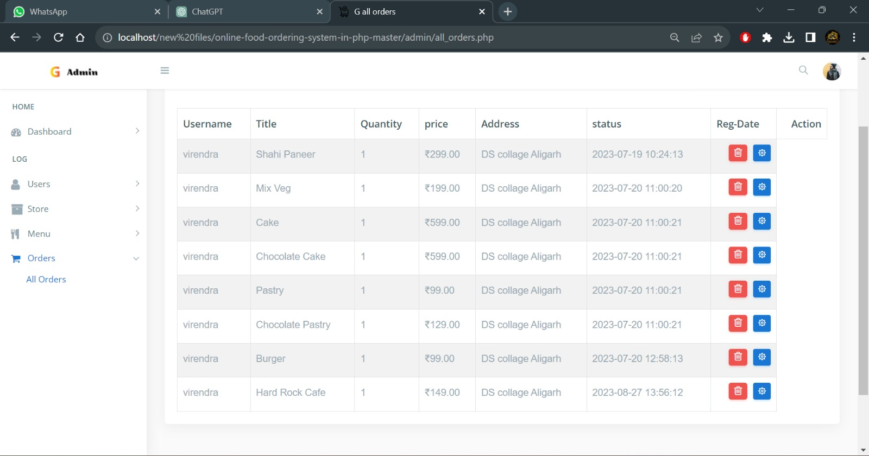

Figure 9.1.3- orders

69
9.1.- All restaurants:
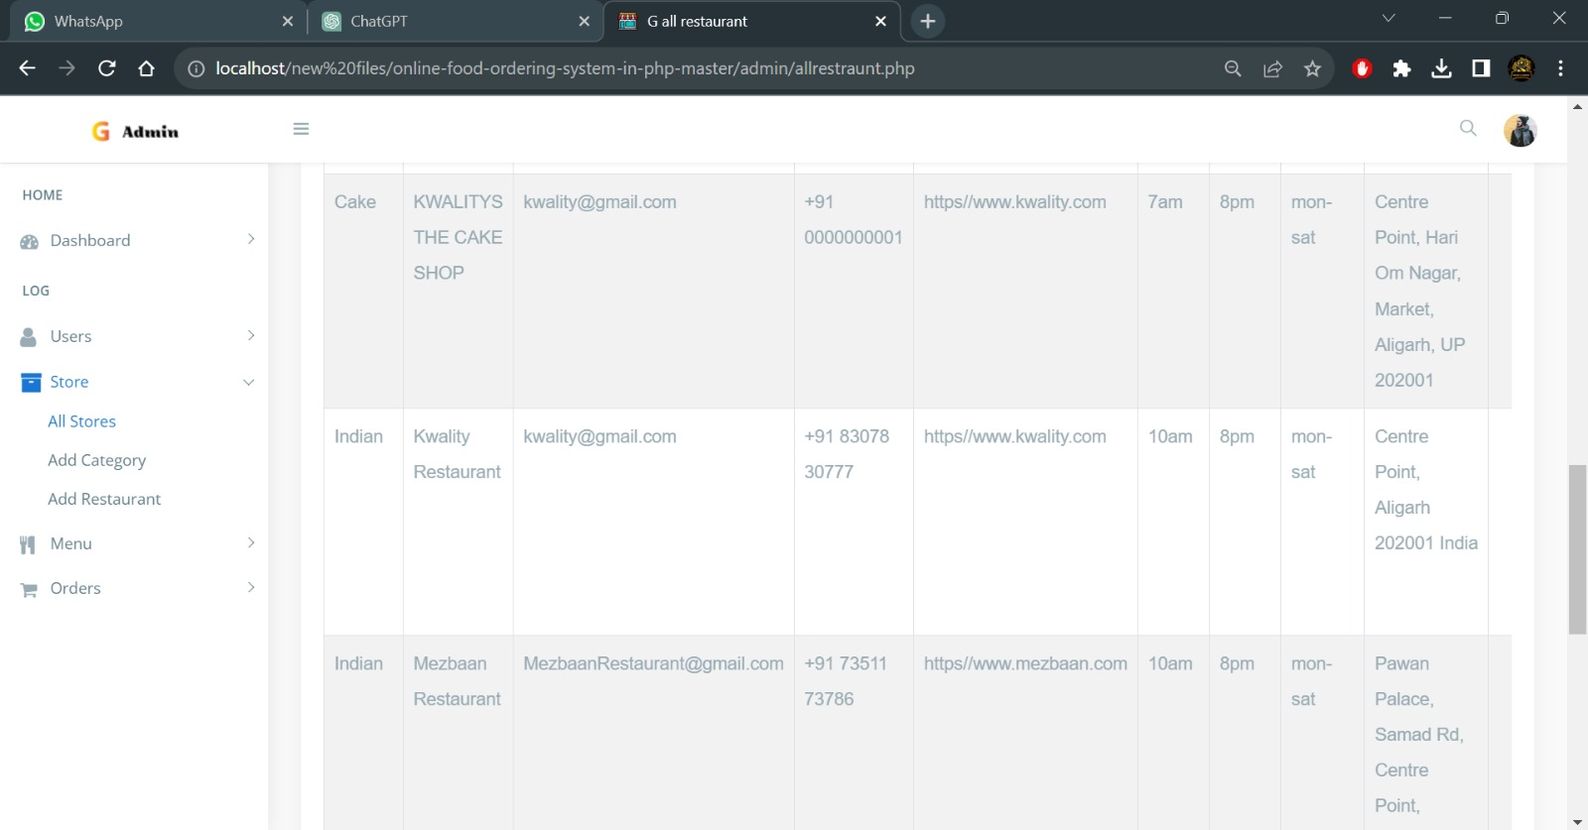

Figure 9.1.4: All restaurants

9.1.5- Home page:

Users can view the website home page.

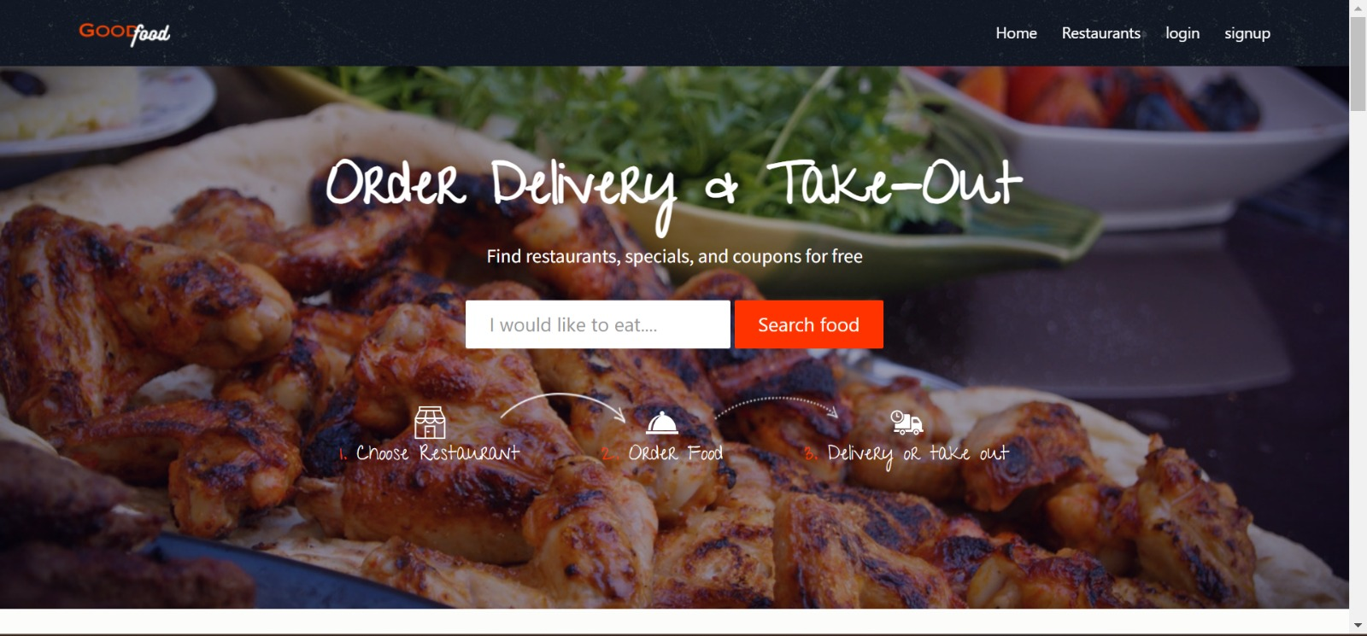

Figure 9.1.5: Home page of the website

70
9.1.6- Food menu:

The user can view the menu and add to cart then order
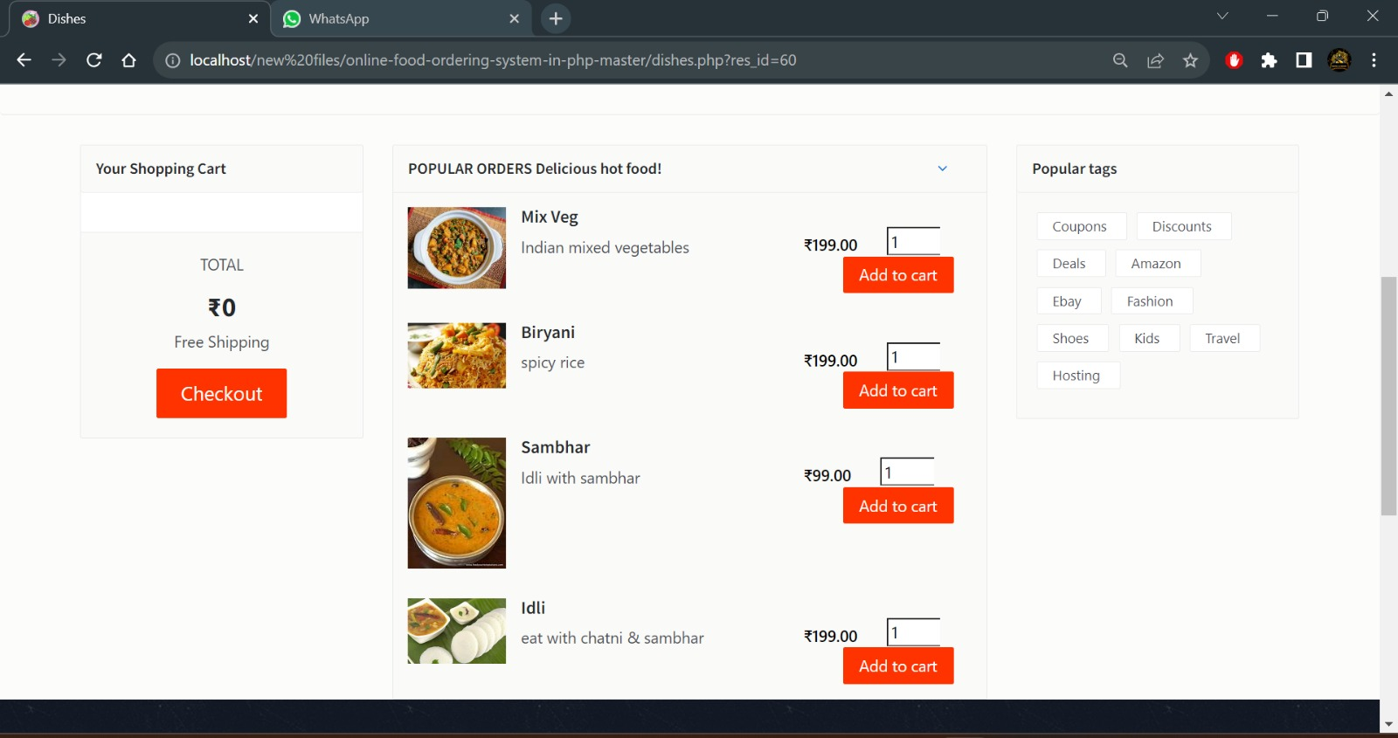

Figure 9.1.6: Food Menu

9.1.7 Restaurants
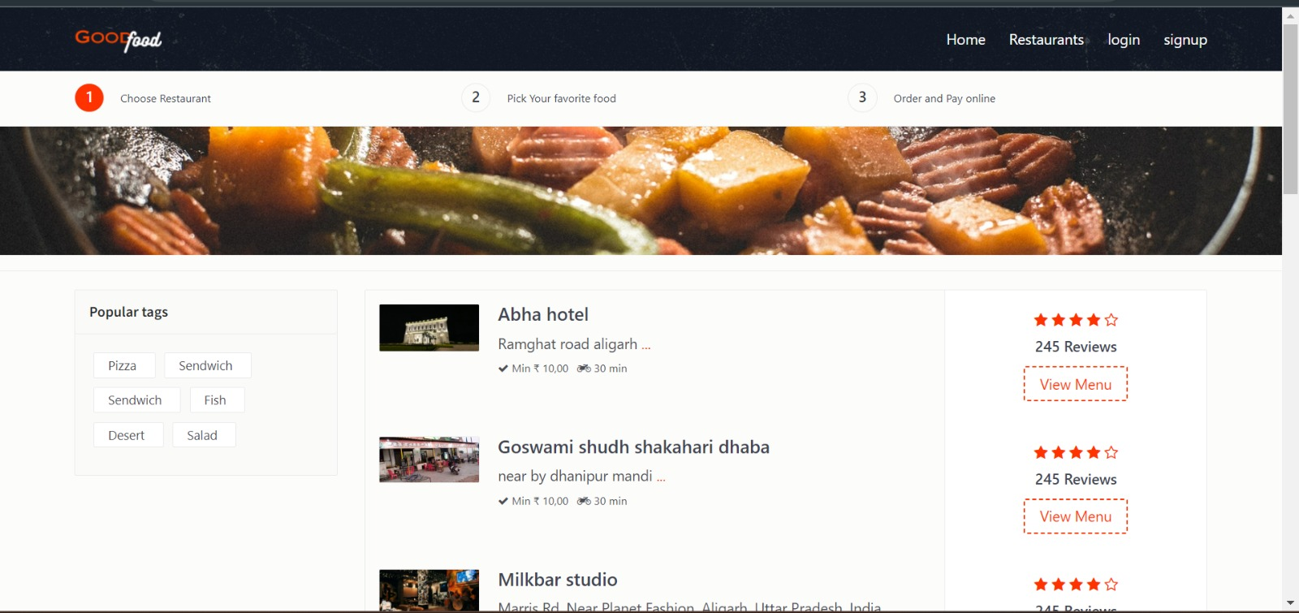
The customer can choose the restaurant

Figure 9.1.7: choose restaurant
71
9.1.8- Registration:
User can register to the website id and then login the id to the good food website.
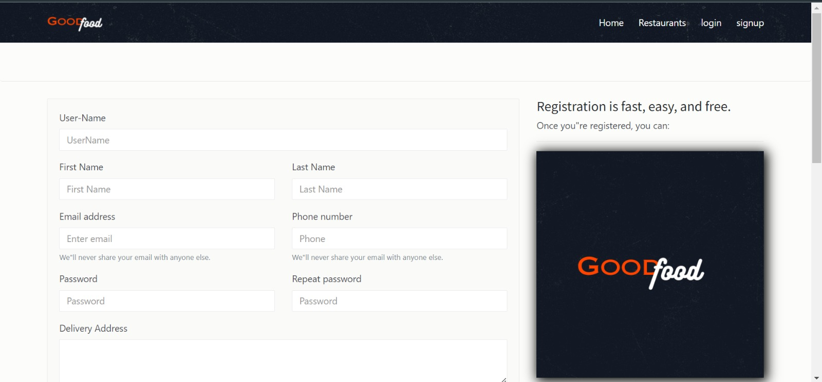

Figure 9.1.8: Registration form
9.1.9- Login:
User can login for order the food and view your orders

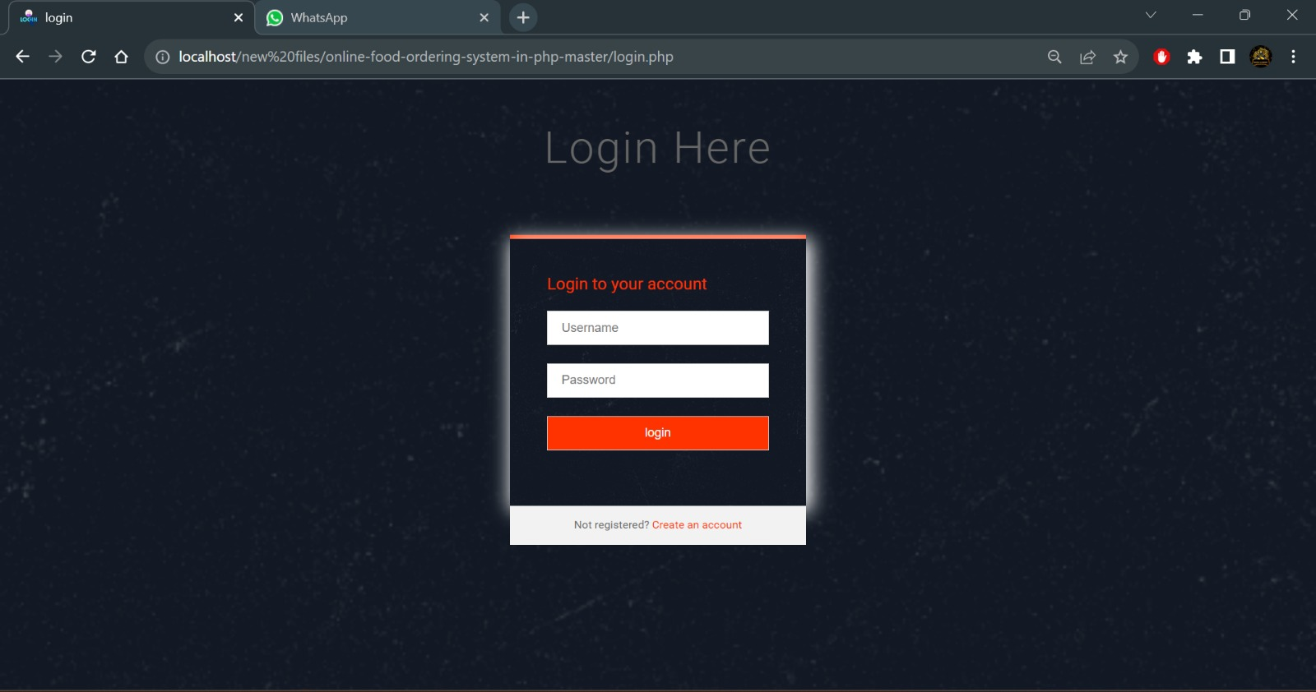
Figure 9.1.9: Login to the website
72
Chapter 10- Coding

Index

<body class="home">

<!--header starts-->
<header id="header" class="header-scroll top-header headrom">
<!-- .navbar -->
<nav class="navbar navbar-dark">
<div class="container">
<button class="navbar-toggler hidden-lg-up" type="button" data-toggle="collapse" data-target="#mainNavbarCollapse">&#9776;</button>
<a class="navbar-brand" href="index.php"> <img class="img-rounded" src="images/good.png" alt=""> </a>
<div class="collapse navbar-toggleable-md float-lg-right" id="mainNavbarCollapse">
<ul class="nav navbar-nav">
<li class="nav-item"> <a class="nav-link active" href="index.php">Home <span class="sr-only">(current)</span></a> </li>
<li class="nav-item"> <a class="nav-link active" href="restaurants.php">Restaurants <span class="sr-only"></span></a> </li>

<?php
if(empty($_SESSION["user_id"])) // if user is not login
{
echo '<li class="nav-item"><a href="login.php" class="nav-link active">login</a> </li>
<li class="nav-item"><a href="registration.php" class="nav-link active">signup</a> </li>';
}
73
else
{
//if user is login

echo '<li class="nav-item"><a href="your_orders.php" class="nav-link active">your orders</a> </li>';

echo '<li class="nav-item"><a href="logout.php" class="nav-link active">logout</a> </li>';
}

?>

</ul>

</div>
</div>
</nav>
<!-- /.navbar -->
</header>
<!-- banner part starts -->
<section class="hero bg-image" data-image-src="images/img/main.jpeg">
<div class="hero-inner">
<div class="container text-center hero-text font-white">
<h1>Order Delivery & Take-Out </h1>
<h5 class="font-white space-xs">Find restaurants, specials, and coupons for free</h5>
<div class="banner-form">
<form class="form-inline">
<div class="form-group">
<label class="sr-only" for="exampleInputAmount">I would like to eat....</label>
<div class="form-group">
<input type="text" class="form-control form-control-lg" id="exampleInputAmount" placeholder="I would like to eat...."> </div>
74
</div>
<button onclick="location.href='restaurants.php'" type="button" class="btn theme-btn btn-lg">Search food</button>
</form>
</div>
<div class="steps">
<div class="step-item step1">
<svg xmlns="http://www.w3.org/2000/svg" viewbox="0 0 483 483" width="512" height="512">
<g fill="#FFF">
<path d="M467.006 177.92c-.055-1.573-.469-3.321-1.233-4.755L407.006 62.877V10.5c0-5.799-4.701-10.5-10.5-10.5h-310c-5.799 0-10.5 4.701-10.5 10.5v52.375L17.228 173.164a10.476 10.476 0 0 0-1.22 4.938h-.014V472.5c0 5.799 4.701 10.5 10.5 10.5h430.012c5.799 0 10.5-4.701 10.5-10.5V177.92zM282.379 76l18.007 91.602H182.583L200.445 76h81.934zm19.391 112.602c-4.964 29.003-30.096 51.143-60.281 51.143-30.173 0-55.295-22.139-60.258-51.143H301.77zm143.331 0c-4.96 29.003-30.075 51.143-60.237 51.143-30.185 0-55.317-22.139-60.281-51.143h120.518zm-123.314-21L303.78 76h86.423l48.81 91.602H321.787zM97.006 55V21h289v34h-289zm-4.198 21h86.243l-17.863 91.602h-117.2L92.808 76zm65.582 112.602c-5.028 28.475-30.113 50.19-60.229 50.19s-55.201-21.715-60.23-50.19H158.39zM300 462H183V306h117v156zm21 0V295.5c0-5.799-4.701-10.5-10.5-10.5h-138c-5.799 0-10.5 4.701-10.5 10.5V462H36.994V232.743a82.558 82.558 0 0 0 3.101 3.255c15.485 15.344 36.106 23.794 58.065 23.794s42.58-8.45 58.065-23.794a81.625 81.625 0 0 0 13.525-17.672c14.067 25.281 40.944 42.418 71.737 42.418 30.752 0 57.597-17.081 71.688-42.294 14.091 25.213 40.936 42.294 71.688 42.294 24.262 0 46.092-10.645 61.143-27.528V462H321z"></path>
<path d="M202.494 386h22c5.799 0 10.5-4.701 10.5-10.5s-4.701-10.5-10.5-10.5h-22c-5.799 0-10.5 4.701-10.5 10.5s4.701 10.5 10.5 10.5z"></path>
</g>
</svg>
<h4><span>1. </span>Choose Restaurant</h4> </div>
<!-- end:Step -->
<div class="step-item step2">
<svg xmlns="http://www.w3.org/2000/svg" width="512" height="512" viewbox="0 0 380.721 380.721">
<g fill="#FFF">

75
<path d="M58.727 281.236c.32-5.217.657-10.457 1.319-15.709 1.261-12.525 3.974-25.05 6.733-37.296a543.51 543.51 0 0 1 5.449-17.997c2.463-5.729 4.868-11.433 7.25-17.01 5.438-10.898 11.491-21.07 18.724-29.593 1.737-2.19 3.427-4.328 5.095-6.46 1.912-1.894 3.805-3.747 5.676-5.588 3.863-3.509 7.221-7.273 11.107-10.091 7.686-5.711 14.529-11.137 21.477-14.506 6.698-3.724 12.455-6.982 17.631-8.812 10.125-4.084 15.883-6.141 15.883-6.141s-4.915 3.893-13.502 10.207c-4.449 2.917-9.114 7.488-14.721 12.147-5.803 4.461-11.107 10.84-17.358 16.992-3.149 3.114-5.588 7.064-8.551 10.684-1.452 1.83-2.928
3.712-4.427 5.6a1225.858 1225.858 0 0 1-3.84 6.286c-5.537 8.208-9.673 17.858-13.995 27.664-1.748 5.1-3.566 10.283-5.391 15.534a371.593 371.593 0 0 1-4.16 16.476c-2.266 11.271-4.502 22.761-5.438 34.612-.68 4.287-1.022 8.633-1.383 12.979 94 .023 166.775.069 268.589.069.337-4.462.534-8.97.534-13.536 0-85.746-62.509-156.352-142.875-165.705 5.17-4.869 8.436-11.758 8.436-19.433-.023-14.692-11.921-26.612-26.631-26.612-14.715 0-26.652 11.92-26.652 26.642 0 7.668 3.265 14.558 8.464 19.426-80.396 9.353-142.869 79.96-142.869 165.706 0 4.543.168 9.027.5 13.467 9.935-.002 19.526-.002 28.926-.002zM0 291.135h380.721v33.59H0z" /> </g>
</svg>
<h4><span>2. </span>Order Food</h4> </div>
<!-- end:Step -->
<div class="step-item step3">
<svg xmlns="http://www.w3.org/2000/svg" width="512" height="512" viewbox="0 0 612.001 612">
<path d="M604.131 440.17h-19.12V333.237c0-12.512-3.776-24.787-10.78-35.173l-47.92-70.975a62.99 62.99 0 0 0-52.169-27.698h-74.28c-8.734 0-15.737 7.082-15.737 15.738v225.043h-121.65c11.567 9.992 19.514 23.92 21.796 39.658H412.53c4.563-31.238 31.475-55.396 63.972-55.396 32.498 0 59.33 24.158 63.895 55.396h63.735c4.328 0 7.869-3.541 7.869-7.869V448.04c-.001-4.327-3.541-7.87-7.87-7.87zM525.76 312.227h-98.044a7.842 7.842 0 0 1-7.868-7.869v-54.372c0-4.328 3.541-7.869 7.868-7.869h59.724c2.597 0 4.957 1.259 6.452 3.305l38.32 54.451c3.619 5.194-.079 12.354-6.452 12.354zM476.502 440.17c-27.068 0-48.943 21.953-48.943 49.021 0 26.99 21.875 48.943 48.943 48.943 26.989 0 48.943-21.953 48.943-48.943 0-27.066-21.954-49.021-48.943-49.021zm0 73.495c-13.535 0-24.472-11.016-24.472-24.471 0-13.535 10.937-24.473 24.472-24.473 13.533 0 24.472 10.938 24.472 24.473 0 13.455-10.938 24.471-24.472 24.471zM68.434 440.17c-4.328 0-7.869 3.543-7.869 7.869v23.922c0 4.328 3.541 7.869 7.869 7.869h87.971c2.282-15.738 10.229-29.666 21.718-39.658H68.434v-.002zm151.864 0c-26.989 0-48.943 21.953-48.943 49.021 0 26.99 21.954 48.943 48.943 48.943 27.068 0 48.943-21.953 48.943-48.943.001-27.066-21.874-49.021-48.943-49.021zm0 73.495c-13.534 0-24.471-
11.016-24.471-24.471 0-13.535 10.937-24.473 24.471-24.473s24.472 10.938 24.472 24.473c0 13.455-10.938 24.471-24.472 24.471zm117.716-363.06h-91.198c4.485 13.298 6.846 27.54 6.846 42.255 0 74.28-60.431 134.711-134.711 134.711-13.535 0-26.675-2.045-39.029-5.744v86.949c0 4.328 3.541 7.869 7.869 7.869h265.96c4.329 0 7.869-3.541 7.869-7.869V174.211c-.001-13.062-10.545-23.606-23.606-23.606zM118.969 73.866C53.264 73.866 0 127.129 0 192.834s53.264 118.969 118.969 118.969 118.97-53.264 118.97-118.969-53.265-118.968-118.97-118.968zm0 210.864c-50.752 0-91.896-41.143-91.896-91.896s41.144-91.896 91.896-91.896c50.753 0 91.896 41.144 91.896 91.896 0 50.753-41.143 91.896-91.896 91.896zm35.097-72.488c-1.014 0-2.052-.131-3.082-.407L112.641 201.5a11.808 11.808 0 0 1-8.729-11.396v-59.015c0-6.516 5.287-11.803 11.803-11.803 6.516 0 11.803 5.287 11.803
76
11.803v49.971l29.614 7.983c6.294 1.698 10.02 8.177 8.322 14.469-1.421 5.264-6.185 8.73-11.388 8.73z" fill="#FFF" /> </svg>
<h4><span>3. </span>Delivery or take out</h4> </div>
<!-- end:Step -->
</div>
<!-- end:Steps -->
</div>
</div>
<!--end:Hero inner -->
</section>
<!-- banner part ends -->

<!-- Popular block starts -->
<section class="popular">
<div class="container">
<div class="title text-xs-center m-b-30">
<h2>Popular Dishes of the Month</h2>
<p class="lead">The easiest way to your favourite food</p>
</div>
<div class="row">

<?php
// fetch records from database to display popular first 3 dishes from table
$query_res= mysqli_query($db,"select * from dishes LIMIT 3");
while($r=mysqli_fetch_array($query_res))
{

echo ' <div class="col-xs-12 col-sm-6 col-md-4 food-item">
77
<div class="food-item-wrap">
<div class="figure-wrap bg-image" data-image-src="admin/Res_img/dishes/'.$r['img'].'">
<div class="distance"><i class="fa fa-pin"></i>1240m</div>
<div class="rating pull-left"> <i class="fa fa-star"></i> <i class="fa fa-star"></i> <i class="fa fa-star"></i> <i class="fa fa-star"></i> <i class="fa fa-star-o"></i> </div>
<div class="review pull-right"><a href="#">198 reviews</a> </div>
</div>
<div class="content">
<h5><a href="dishes.php?res_id='.$r['rs_id'].'">'.$r['title'].'</a></h5>
<div class="product-name">'.$r['slogan'].'</div>
<div class="price-btn-block"> <span class="price">₹'.$r['price'].'</span> <a href="dishes.php?res_id='.$r['rs_id'].'" class="btn theme-btn-dash pull-right">Order Now</a> </div>
</div>

</div>
</div>
}
?>

</div>
</div>

78

</section>
<!-- Popular block ends -->
<!-- Bootstrap core JavaScript
================================================== -->
<script src="js/jquery.min.js"></script>
<script src="js/tether.min.js"></script>
<script src="js/bootstrap.min.js"></script>
<script src="js/animsition.min.js"></script>
<script src="js/bootstrap-slider.min.js"></script>
<script src="js/jquery.isotope.min.js"></script>
<script src="js/headroom.js"></script>
<script src="js/foodpicky.min.js"></script>
</body>
</html>

Login
<body>
<?php
include("connection/connect.php"); //INCLUDE CONNECTION
error_reporting(0); // hide undefine index errors
session_start(); // temp sessions
if(isset($_POST['submit'])) // if button is submit
{
$username = $_POST['username']; //fetch records from login form
$password = $_POST['password'];

if(!empty($_POST["submit"])) // if records were not empty
{
$loginquery ="SELECT * FROM users WHERE username='$username' && password='".md5($password)."'"; //selecting matching records
$result=mysqli_query($db, $loginquery); //executing
$row=mysqli_fetch_array($result);
79
if(is_array($row)) // if matching records in the array & if everything is right
{
$_SESSION["user_id"] = $row['u_id']; // put user id into temp session
header("refresh:1;url=index.php"); // redirect to index.php page

}
else
{
$message = "Invalid Username or Password!"; // throw error
}
}
}
?
<!-- Form Mixin-->
<!-- Input Mixin-->
<!-- Button Mixin-->
<!-- Pen Title-->
<div class="pen-title">
<h1>Login Here</h1>
</div>
<!-- Form Module-->
<div class="module form-module">
<div class="toggle">
</div>
<div class="form">
<h2>Login to your account</h2>
<span style="color:red;"><?php echo $message; ?></span>
<span style="color:green;"><?php echo $success; ?></span>
<form action="" method="post">
<input type="text" placeholder="Username" name="username"/>
<input type="password" placeholder="Password" name="password"/>
<input type="submit" id="buttn" name="submit" value="login" />
80
</form>
</div>
<div class="cta">Not registered?<a href="registration.php" style="color:#f30;"> Create an account</a></div>
</div>
<script src='http://cdnjs.cloudflare.com/ajax/libs/jquery/2.1.3/jquery.min.js'></script>

Logout
<?php
session_start(); //start session
session_destroy(); // distroy all the current sessions
$url = 'login.php';
header('Location: ' . $url); // redireted to login page

?>
Admin Connection file
<?php
//main connection file for both admin & front end
$servername = "localhost"; //server
$username = "root"; //username
$password = ""; //password
$dbname = "online_rest"; //database

// Create connection
$db = mysqli_connect($servername, $username, $password, $dbname); // connecting
// Check connection
if (!$db) { //checking connection to DB
die("Connection failed: " . mysqli_connect_error());
}

?>

81
Index
<!DOCTYPE html>
<html lang="en" >
<?php
include("../connection/connect.php");
error_reporting(0);
session_start();
if(isset($_POST['submit']))
{
$username = $_POST['username'];
$password = $_POST['password'];

if(!empty($_POST["submit"]))
{
$loginquery ="SELECT * FROM admin WHERE username='$username' && password='".md5($password)."'";

$result=mysqli_query($db, $loginquery);
$row=mysqli_fetch_array($result);

if(is_array($row))
{
$_SESSION["adm_id"] = $row['adm_id'];
header("refresh:1;url=dashboard.php");
}
else
{
$message = "Invalid Username or Password!";
}
}

}
82
if(isset($_POST['submit1'] ))
{
if(empty($_POST['cr_user']) ||
empty($_POST['cr_email'])||
empty($_POST['cr_pass']) ||
empty($_POST['cr_cpass']) ||
empty($_POST['code']))
{
$message = "ALL fields must be fill";
}
else
{

$check_username= mysqli_query($db, "SELECT username FROM admin where username = '".$_POST['cr_user']."' ");

$check_email = mysqli_query($db, "SELECT email FROM admin where email = '".$_POST['cr_email']."' ");

$check_code = mysqli_query($db, "SELECT adm_id FROM admin where code = '".$_POST['code']."' ");

if($_POST['cr_pass'] != $_POST['cr_cpass']){
$message = "Password not match";
}
elseif (!filter_var($_POST['cr_email'], FILTER_VALIDATE_EMAIL)) // Validate email address
{
$message = "Invalid email address please type a valid email!";
}
elseif(mysqli_num_rows($check_username) > 0)
{
$message = 'username Already exists!';
}
83
elseif(mysqli_num_rows($check_email) > 0)
{
$message = 'Email Already exists!';
}
if(mysqli_num_rows($check_code) > 0) // if code already exist
{
$message = "Unique Code Already Redeem!";
}
else{
$result = mysqli_query($db,"SELECT id FROM admin_codes WHERE codes = '".$_POST['code']."'"); //query to select the id of the valid code enter by user!

if(mysqli_num_rows($result) == 0) //if code is not valid
{
// row not found, do stuff...
$message = "invalid code!";
}

else //if code is valid
{

$mql = "INSERT INTO admin (username,password,email,code) VALUES ('".$_POST['cr_user']."','".md5($_POST['cr_pass'])."','".$_POST['cr_email']."','".$_POST['code']."')";
mysqli_query($db, $mql);
$success = "Admin Added successfully!";

}
}
}
}
?>
84
<head>
<meta charset="UTF-8">
<link rel="icon" href="https://i.postimg.cc/05JcsRyf/manager.png">
<title>Admin Login </title>

<link rel="stylesheet" href="https://cdnjs.cloudflare.com/ajax/libs/meyer-reset/2.0/reset.min.css">

<link rel='stylesheet prefetch' href='https://fonts.googleapis.com/css?family=Roboto:400,100,300,500,700,900'>
<link rel='stylesheet prefetch' href='https://fonts.googleapis.com/css?family=Montserrat:400,700'>
<link rel='stylesheet prefetch' href='https://maxcdn.bootstrapcdn.com/font-awesome/4.3.0/css/font-awesome.min.css'>

<link rel="stylesheet" href="css/login.css">

<style>
body{
background-color: black;
}
.form{
background-image:url("https://i.postimg.cc/QxMXYbbc/pattern.png");
background-size: cover;
background-repeat: no-repeat;
box-shadow: 4px 4px 50px 4px green;
}
.hint{
color: white;

}
</style>
</head>

85
<body>
<div class="container">
<div class="info">
<h1>Administration </h1><span> login Account</span>
</div>
</div>
<div class="form">
<div class="thumbnail"><img src="images/manager.png"/></div>

<form class="register-form" action="index.php" method="post">
<input type="text" placeholder="username" name="cr_user"/>
<input type="text" placeholder="email address" name="cr_email"/>
<input type="password" placeholder="password" name="cr_pass"/>
<input type="password" placeholder="Confirm password" name="cr_cpass"/>
<input type="password" placeholder="Unique-Code" name="code"/>
<input type="submit" name="submit1" value="Create" />
<p class="message">Already registered? <a href="#">Sign In</a></p>
</form>
<span class="hint">username:admin</span>&nbsp;<span class="hint">password:1234</span>
<span style="color:red;"><?php echo $message; ?></span>
<span style="color:green;"><?php echo $success; ?></span>
<form class="login-form" action="index.php" method="post">
<input type="text" placeholder="username" name="username"/>
<input type="password" placeholder="password" name="password"/>
<input type="submit" name="submit" value="login" />
<p class="message">Not registered? <a href="#">Create an account</a></p>
</form>

</div>
<script src='http://cdnjs.cloudflare.com/ajax/libs/jquery/2.1.3/jquery.min.js'></script>
<script src='js/index.js'></script>

86
Chapter 11- Testing
Introduction
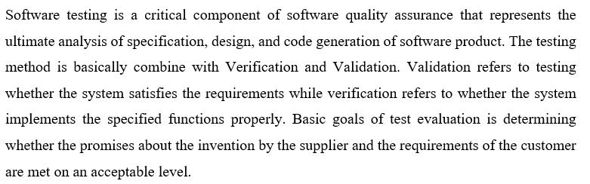

11.1- Testing Procedure:

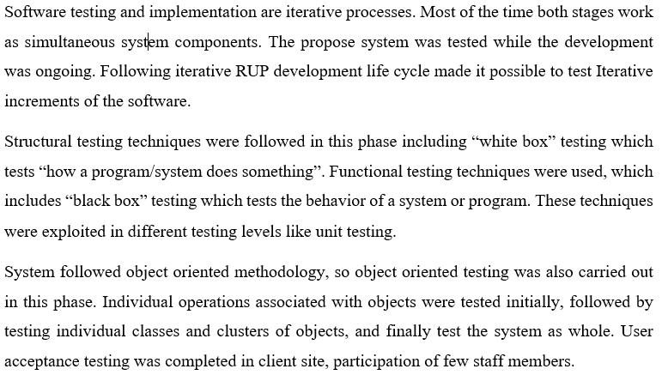

11.2- Test Plan and Test Cases:

Implementation stage starts the testing process. In development stage code is reviewed. Test plan included all phases of testing and also used as a guide for the overall testing process. The test plan was designed before the implementation of the system. Test Objectives, Test Schedule test Logistics and Test Strategies are included in Test plan. Test cases are highly considered in here.

87
1. User Registration and Login:
- Test Case 1: Verify that a user can successfully register with valid information.
- Test Case 2: Verify that a user can log in using correct credentials.
- Test Case 3: Verify that incorrect login credentials result in an error message.
2. Menu Browsing and Selection:
- Test Case 4: Verify that the user can browse the menu and view available items.
- Test Case 5: Verify that the user can add items to the cart.
- Test Case 6: Verify that the cart updates correctly when items are added or removed.
3. Ordering Process:
- Test Case 7: Verify that the user can proceed to checkout from the cart.
- Test Case 8: Verify that the user can select a delivery address during checkout.
- Test Case 9: Verify that the user can choose a payment method.
4. Order Placement:
- Test Case 10: Verify that the user can confirm the order and receive an order confirmation.
- Test Case 11: Verify that the user receives an estimated delivery time.
5. Account Management:
- Test Case 12: Verify that the user can view and edit their profile information.
- Test Case 13: Verify that the user can change their password.
6. Search Functionality:
- Test Case 14: Verify that the search bar can correctly find items by name or keywords.
- Test Case 15: Verify that the search results are accurate and relevant.
7. Special Offers and Discounts:
- Test Case 16: Verify that special offers and discounts are applied correctly to the order.
8. Payment Processing:
- Test Case 17: Verify that the user can complete the payment process successfully.
- Test Case 18: Verify that the user receives a payment confirmation.
9. Order Tracking:

- Test Case 19: Verify that the user can track the status of their order in real-time.
10. Mobile Responsiveness:
- Test Case 20: Verify that the website is responsive and works correctly on mobile devices.
11. Accessibility:
- Test Case 21: Verify that the website meets accessibility standards for users with disabilities.
12. Error Handling:
- Test Case 22: Verify that appropriate error messages are displayed for invalid inputs or actions.

11.3- Master Data modules:

These tables tabulate some of the test cases for testing basic functions.

88
Table: Add customer test case
Test Case ID |  | 1
Tested Component |  | Add Customer
Module Name |  | Customer Module
Test Case |  | Add new customer
Expected output |  | Add customer successfully, View should be user friendly. If adding
 |  | customer form missing any required information error massage must
 |  | be displayed.
Test Case Description
No | Test Case | Actual Output | Status
01 | (Positive) | Enter customer information (Title, First Name, Last | Pass
 | Add customer | Name, Street, Town, Phone No, Email, Remarks)
 | success
 |  | (Title, First Name, Last Name, Street, Town, Phone No,
 |  | Email, must be filled save customer)
 |  | Validate
 |  | Then redirect to relevant home page
 |  | (Admin – Add customer)
02 | Negative | Enter customer information (Title, First Name, Last | Pass
 | Log-In | Name, Street, Town, Phone No, Email, Remarks
 | Not success | (Not valid)
 |  | Text box show error Message- “Required field”
 |  | 89

Chapter 12- Bibliography

Online food ordering systems have become increasingly popular in recent years. When creating a bibliography for a project on this topic, we include some sources that we have consulted during our research. Here's an example of bibliography, including different types of sources:

Websites:
We completed our project by taking the help of following websites:
- www.google.com
- www.youtube.com
- www.chat.openai.com
- www.useblackbox.io
- www.getbootstrap.com

90

